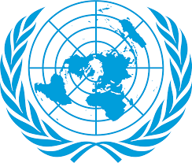
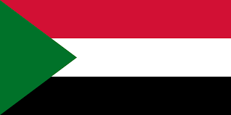
Commitee: WHO
Agenda Item: Legalization of Euthanasia
Country: Sudan
Delegate: Münir Arcagök

The Republic of Sudan is the third largest country in Africa. The south of the country has rich oil deposits, while the north is mostly desert. Sudan is the gateway to Africa. With 39.58 million inhabitants, the vast majority of the people are Arabs.
Troughout these years euthanasia has become a more actively debated issue. In Sudan, euthanasia and assisted suicide are illegal. Neither the lay community nor the medical profession has been exposed to the international debate on these issues. Muslims strictly believe that only god should terminate their lives. The Muslim majority in the country reinforces this view. According to surveys, 85% of doctors in Sudan are against euthanasia and passive suicide. The reasons given by respondants for their opposition to legalizing euthanasia and assisted suicide are mostly; religious beliefs, inconsistent with the doctor’s role in life preseruation and fear of not adhering to prescribed requirements.

Euthanasia should not be a solution. The development and expansion of palliative care will eliminate the need for euthanasia. The best solution would be for the United Nations to allocate a budget for this issue.

