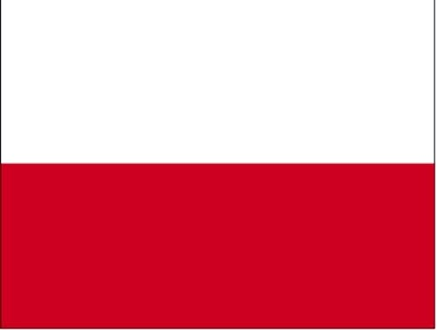
Country: The Republic of Poland

Committee: The United Nations Development
Programme

Topic: Achieving SustainableDevelopment
Goals 8 and 9

The economy of a country is of great importance for the welfare and level of happiness of its citizens.The financial situation to support the health expenses is vital as the citizens of Poland are most likely to be influential. The Polish state with the other 12 areas of the country isin the process of economical growth and development. Yet the country wants to increase the momentum of the current growth. It is a special occasion for Poland to present to the international community of their achievements on the road to sustainable development. Their performance can contribute to the global process of building of global sustainable economy.

The economy of Poland is a kind of mixed economy with a developed market that serves as the sixth-largest in the European Union and the fifth-largest in terms of GDP. Poland boasts extensive public services as one of the characteristics ofthe most developed economies. During economic transformation in the 1990s, Poland benefited from financial support provided by other countries and the international community. In an experiment we have carried out, we have built a platform for identifying and sharing innovative solutions. Our goal goal is to facilitate the transfer of Polish know-how, technology by pulling from the private sector. The purpose of this activity is to identifya promising innovative solution at scale and address the challenges in the process of development as well as to point out the immediate needs of the Republic of Moldova which creates a negative impact on Ukraine.

We support local shops to integrate them in the new globalized economy system . In this way, we aim to avoid their limitation in the market when small shops are concerned. Our approach in this sense also fosters to establish partnerships for employment. Based on the success of transformation, our proposal as Poland is:

- To hold a public campaign to trigger public support for Polish aid as a part of Developmental Goals.
- To hold a campaign to thelp other countries with the slogan of ‘’Time to Help the Others’’ as a part of Millennium Development Goals

This solution-oriented policy created by Poland remains inadequate and inefficient due to structural problems, excess workforce, inefficient small farms and lack of investment but recently foreign investments in energy have started to change the future. Recent adjustments in health care, education, and government have resulted in higher-than-expected financial pressures. Improving this account deficit and tightening monetary policy with a focus on inflation are priorities for the Polish government.Poland has started to move forward by leaving behind its past financial difficulties and wants to access and benefit from any resources that the Polish government can provide. With this prospective ,weare ready to exhibit a cooperative attitude hand in hand with no only the Poles but also with the countries in the area.
BIBLIOGRAPHY
https://www.undp.org/eurasia/about-us/partners/polish-undp-partnerships
https://wiser.directory/organization/united-nations-development-programme-undp-project-office-in-poland/
https://unric.org/en/sdg-8/
https://link.springer.com/article/10.1007/s11625-022-01112-3

