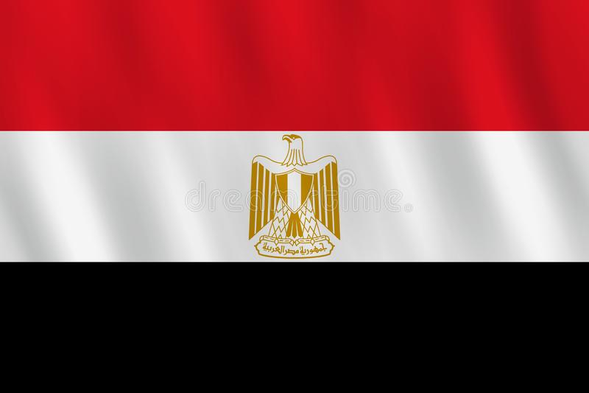
Committe:WHO
Country: Egypt
Topic: Legislation of Euthansia in Egypt
The country of Egypt is a country located in the North east past of Africa. It was founded around the The Nile. Medical papayri is one of the most imporant sorces for learning about Egyptin medicine. Health service in Egypt are divided into three as public goverment, public institutional and private sector. In additional to the three sectors, there are advisory councils as well.
In our country there are great many illnesses . Some of them are Hepatitis C, Trachoma, Malaria, Diarrhea and Acute Respiratorty Disease. More important problms are tuberculosis and HIV. Known as tuberculosis among people; It is an infectious disese that occcurs when bacteria called. Mycobacterium Tuberculosis enters the body from outside. Once the bacteria, which is mainly transmitted from the respiratory system, spreads in the lungs of the person , it subsequently causes the development of inflammation in the lungs. According to the WHO’s data, about 2.5% ofthe patients in the world suffers from tuberculousis. This illness is seen everywhere but especially in Southeast Asia and Africa. The reasons of the illness are unkown but various enviromental causes are possible. The increase rate of the deficiency in the immune system such as AIDS disease is mostly observed throughout the world. So the probability of this disease is much higher in people suffering from AIDS or simmilar immunosuppressive illnesses. Patients who inherit weak immumne system in comparison with other people are more likely to catch the illness. According to the latest WHO results published in 2020 , HIV/AIDS death cases in Egypt reached 397 or 0.07% of total deaths.
To prevent the contamination of tuberculosis, people with active tuberclosis disease should be diagnosed as early as possible. Diagnosis and effective treatment are the most important issues. For the diagnosis of tuberculosis, ARB examination should be done in the sputum as soon as possible and the test must be completed on the same day. Patients at the same time to use protective drug theraphy. The ultimate protection against the illness can be obtained with vaccination starting from chilhood age. Despite these measures, there may be people who can not be protected from the disease depending on the circumstances they are exposed to, or who can not overcome the disease because of the fatal condition they are in . In this case, some countries accept their patients’ demand to be euthanized.Although euthanasia is not an accepted, legal practice worldwide, it is legal and carried out in countries like The Netherlands, Belgium, and and The US state of Texas which is not welcomed in our country . The religion of Islam is active in Egypt. Due to the requirements of Islamic law, euthanasia is not acceptable and not allowed. This is accepted as opposing God. In the framework of our both social and religious way of living, euthanasia is rejected . If I were a country who believed in a religion against euthanasia, I would allocate a budget for patients to spend their last days more comfortably.

BIBLIOGRAPHY
nek.istanbul.edu.tr
hsgm.saglik.gov.tr
www.worldlifeexpectancy.com
www.ankemdernegi.org.tr
www.cerrahi.com.tr

