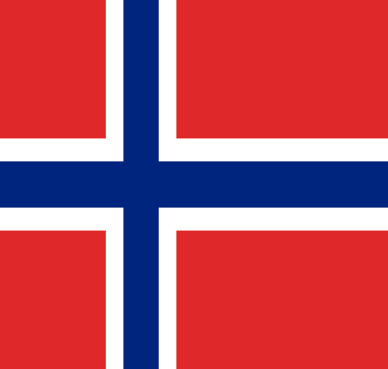

Country: The Republic of Norway
Committee:The United Nation Development Programme
Topic: Achieving Sustainable Development Goals 8 and 9
Norway is a country in the west of the Scandinavian Peninsula located in Northern Europe. Neighboring Finland, Sweden and Russia. The country has a coast on the Norwegian Sea, streaching towards the Atlantic Ocean, to the west. We do not want to join the European Union because we already have high standards of living and economic development above the European average. We are known for the richness of the oil reserves on our shores and the possession of the world and European fisheries sector. In other words, Norway has a pretty good economy.

Economic development should have a positive impact on the whole planet.This is why,financial improvement creates decent and exemplary work to the World.We must protect workers rights and put an end for all.A Norwegian manufacturer Vestre completed The Plus, the world's most environmentally friendly furniture factory, within just 18 months. The factory will be a global showcase for sustainable and high-efficiency production and an experience destination for people around the world.

In order to obtain more efficient results from the work, it is necessary to abolish long working hours, that is, to put an end to modern slavery. Child labor must end by 2025.Safe and secure working environment should be provided for all workers, including migrant workers, especially female migrants and those in precarious employment.

BIBLIOGRAPHY
https://sustainabledevelopment.un.org/memberstates/norway
https://sdgs.un.org/goals/goal8
https://globalgoals.org/goals/8-decent-work-and-economic-growth/

