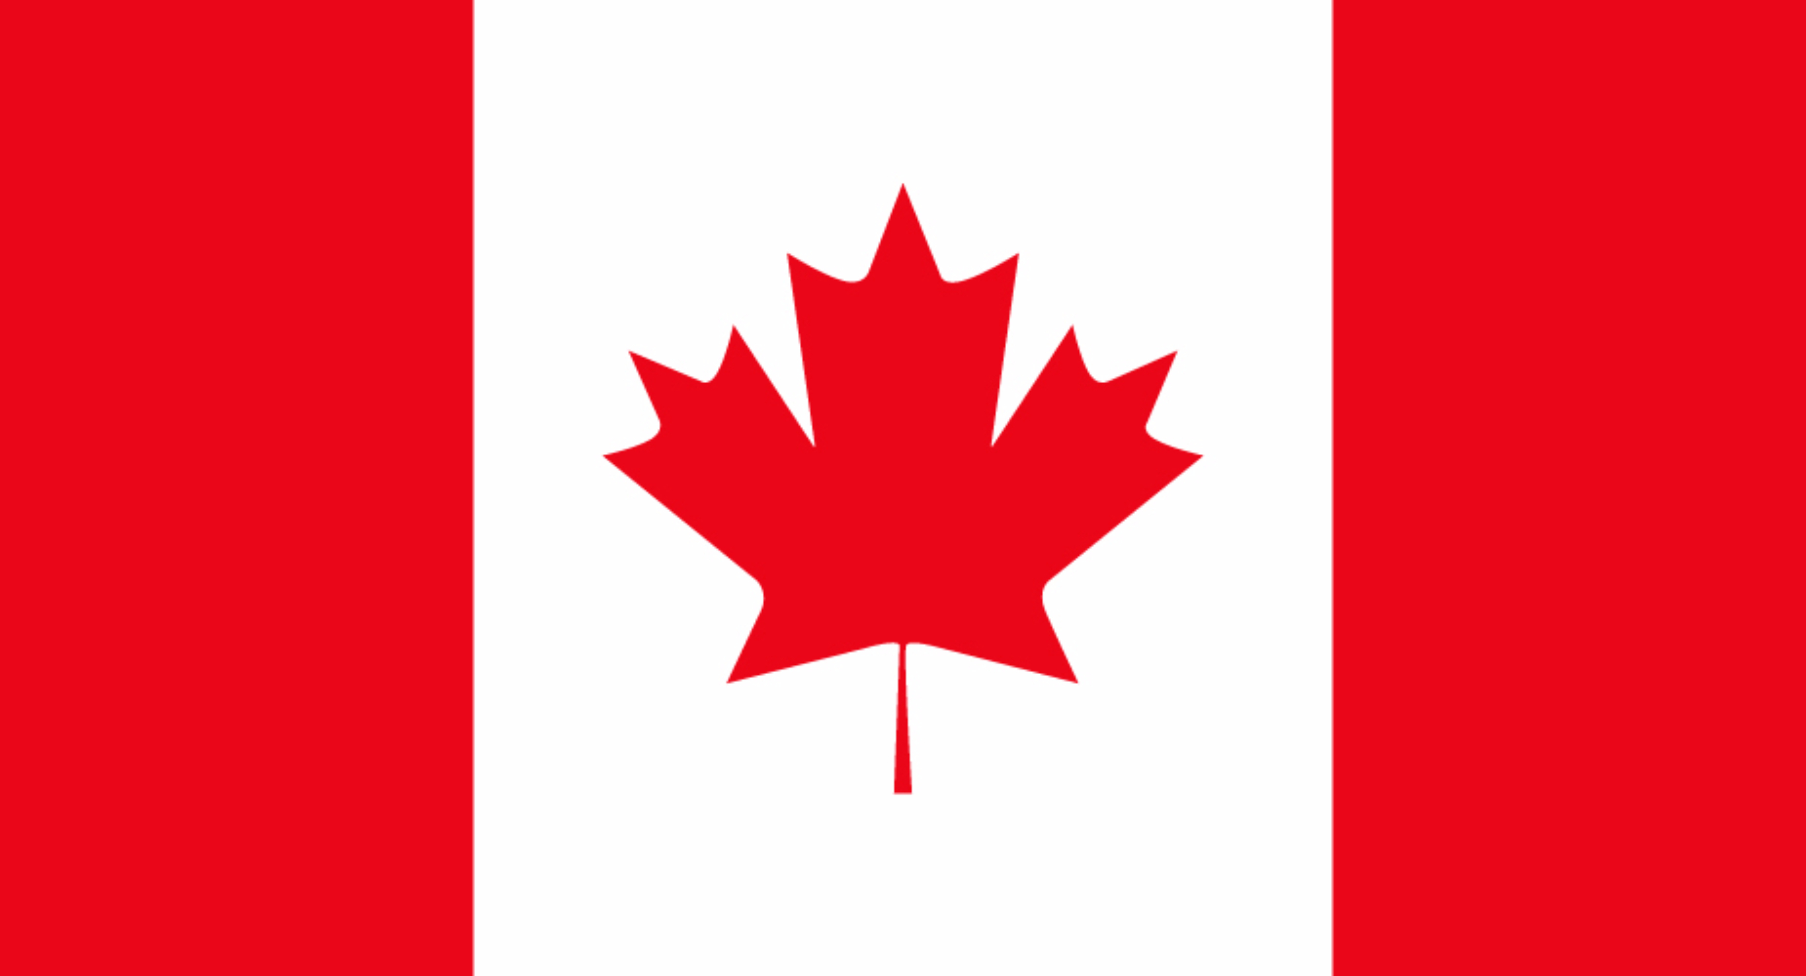
Conferance= Ted University Training and Development Conference
Committee= NATO
Counrty= Canada

POSITION PAPER

NATO (North Atlantic Treaty Organization), is a security alliance of 30 countries from North America and Europe. Nato’s fundamental goal is to safeguard the allies’ freedom and security by political and military needs. The organization is supporting common values such as individual liberty, human rights, democracy and the rule of law. Canada was a founding member of the alliance and has remained as a member since its inception. The Canadian armed forces are among the most engaged, agile, deployable and responsive armed forces within NATO.
Indo-Pasific is where the Indian and the Pasific oceans combine into a singular regional construct. However, since 2010, the term “Indo-Pasific” gained a new meaning for policy makers, analysts and academics. It is now being used to describe geopolitical and strategic discourse. Indo-Pasific is an important place for the world since it is on the list for being one of the best places for economical reasons. As the countries started to notice this, the place seen rapid urbanization and economic growth. Additionally, the Indo-Pasific area became home to half of the world’s population, with China and India making up close to a third of that total. The Indo-Pasific is also important for the North Atlantic Alliance since the developments in that region can directly affect Euro-Atlantic security. With the assertiveness of China growing day by day and having caused an obvious full-scale invasion, Nato made great progress in thinking about China and came to an understanding that they have to finalize their relations with China and encourage its members to take precautions to make sure that Chinese investments do not prevent the Alliance’s ability to use any other crucial infrastructure in the case of a crisis.
1 in 5 Canadians have family ties to the region. Canada’s second-largest regional export market and trading partners after U.S. Overall, Canada will defend its national interests while also focusing on trade, investment, peace, security, military presence, sustainability and regional partnership. The Indo-Pasific region will play a critical role in shaping Canada’s future over the next half-century. The Indo-Pasific region is the world’s fastest growing-region and home to six of Canada’s top 13 trading partners. The region represents significant opportunities for growing the economy, as well as opportunities for Canadian workers and businesses for decades to come.

