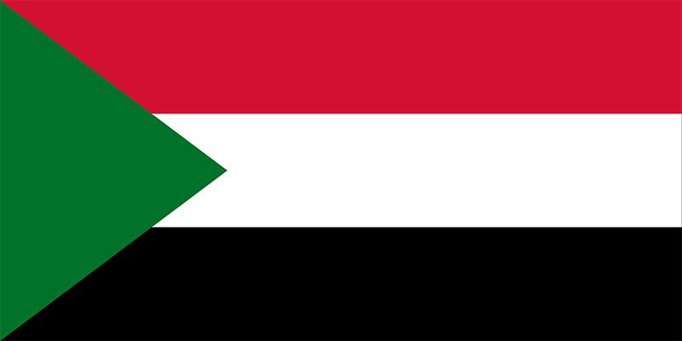
Delegation: Sudan
Committee: UN WOMEN
Agenda Item: Gender Related Mobing

The Republic of the Sudan is located in north-eastern Africa between Egypt and Eritrea, bordering the Red Sea in north east.
It is bordered by Libya in north west, by Chad in west, by the Central African Republic in south west, by South Sudan in south and by Ethiopia in south east. The current populatıon of cuba ıs 38.4 million people. Capital city is Khartoum,spoken languages are Sudanese Arabic ( the predominant language in country ) and Beja (Bendawi). Sudan's female population amounted to approximately 24.47 million. Sınce our women populatıon is dominating the populatıon, women rights and mobbing is very ımportant for us.

Nearly half (46.5%) of the population (mostly womens) of Sudan falls below the poverty line. The 2013 Human Development Report shows Sudan with a low Human Development Index (HDI) ranking of 171 out of 183 countries despite its much higher ranking National Income (GNI). In addition, Sudan ranks 129 among 148 countries on the Gender Inequality Index in the report.Women’s political participation has increased as a result of provisions within the Interim National Constitution and the Elections Act of 2008, which mandate 25% representation of women in parliament. This has resulted in a marked increase of women parliamentarians now exceeding the quota at 28%, but short of the international threshold of 33% women's representation in parliament. Violence against Women and Girls (VAWG) is regarded as a prevalent and critical hindering factor for human development and peace-building in Sudan. The country has a weak normative framework regarding (VAWG), as it is not a state party to the Convention on the Elimination of All forms of Discrimination Against Women (CEDAW). Women are disproportionately affected by the various conflicts and security situations across the country; yet their involvement in leadership and participation in peace talks, conflict resolutions, and peace building continue to reflect only token treatment.

We aim to influence the constitutional, legal and policy frameworks to increase women’s leadership and political participation in Sudan, as well as increasing women’s participation in local and national elections. This programme will contribute to building leadership capacities of women in parliament, parties and gender advocates to better influence policies and enhance women’s participation in the constitutional review process. We aim to strengthen women’s economic empowerment through the adoption and implementation of national plans, legislations, policies, strategies and budgets. This programme also aims to enhance women’s sustainable livelihoods through gender-responsive services and access to and control over means of production, resources and markets. We support initiatives to help women at all levels enhance their employment opportunities, sustainable livelihoods and resilience, including support for microcredit grants. UN Women Sudan advocates for laws, policies and strategies to be developed, adopted and implemented to respond to violence against women and girls. We also aim for women and girl survivors of gender-based violence to access survivor-focused services. In Sudan, the policy environment for addressing violence against women is weak due to sensitivities on data collection, International Criminal Court (ICC) indictments against key government officials alleging violations of human rights including violence against women and stigma associated with violence against women.

