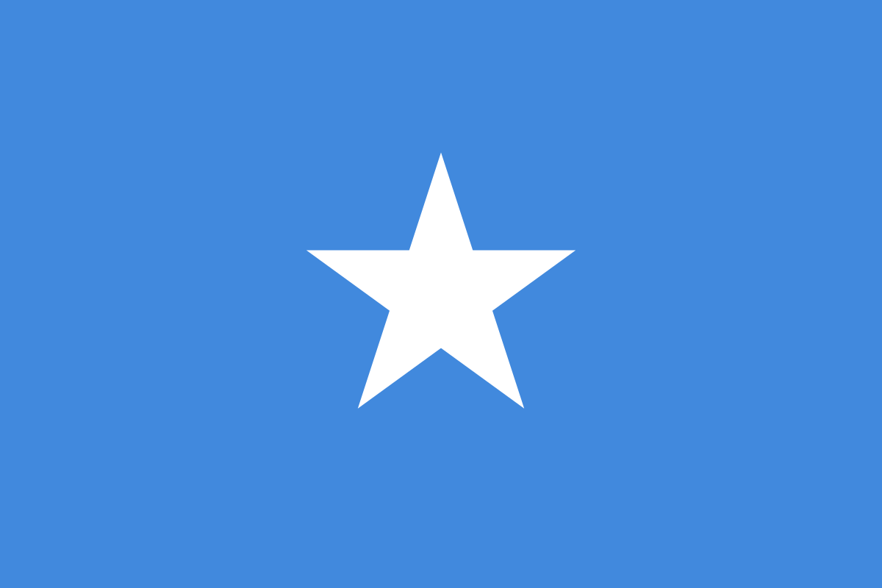
Country:Somalia
Committee:UNWOMEN
Agenda Item:Gender Related Mobbing
Delegate:Buğra Demircan

Somalia officially the Federal Republic of Somali is a country in the Horn of Africa. The country is bordered by Ethiopia to the west, Djibouti to the northwest, the Gulf of Aden to the north, the Indian Ocean to the east, and Kenya to the southwest. Somalia has the longest coastline on Africa's mainland. Somalia has an estimated population of around million, of which over million live in the capital and largest city Mogadishu, and has been described as Africa's most culturally homogeneous country. Around 85% of its residents are ethnic Somalis, who have historically inhabited the country's north. Ethnic minorities are largely concentrated in the south. The official languages of Somalia are Somali and Arabic. Most people in the country are Muslims, the majority of them Sunni.

Mobbing, as a sociological term, means bullying of an individual by a group, in any context, such as a family, peer group, school, workplace, neighborhood, community, or online. Mobbing has become rampant in all places all around the world. Resarches say that mobbing can be done in various gender groups but women victims are more than men.

Life for women and girls in Somalia is challenging. Somalia ranks fourth lowest for gender equality globally, maternal and infant mortality rates are some of the highest in the world, and early marriage is prevalent. The Somalia Health and Demographic Survey (SHDS) shows that Female Genital Mutilation/Cutting in women aged 15–49 is high,at 99%which has both short-term and long-term physiological, sexual and psychological repercussions. Sexual and Gender-Based Violence is one of the most prevalent human rights violations faced by people, particularly women, all around the globe.To address some of the challenges, in 2018, the Federal Parliament introduced the comprehensive Sexual Offences Bill (SOB), which if approved during the 11th Parliament, would offer greater protection for the victims of sexual violence and would represent a significant step toward ending the culture of impunity as it relates to GBV in Somalia.
Other aspects of the challenges that women face in accessing justice are the Somali culture, which restricts women to the home and family sphere; differing interpretations of judicial regimes, like sharia, secular and customary law; and the absence of women within the judicial system. Out of a total of 295 judges there exist 2 female judges and out of a total of 65 prosecutors 14 female prosecutors as of 2021 calling for attention for gender parity
UN Women works towards making the vision of the Sustainable Development Goals a reality for women and girls and stands behind women’s equal participation in all aspects of life.
REFERENCES:
https://en.wikipedia.org/wiki/Mobbing
https://africa.unwomen.org/en/where-we-are/eastern-and-southern-africa/somalia
https://en.wikipedia.org/wiki/Somalia

