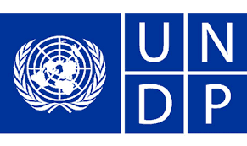

Country: Qatar
Committee: United Nations Development Program
Agenda Item: Goal 8 and Goal 9
Delegate: Alp ÖZTÜRK

We, as the delegation of the Qatar are happy with the situation of the Goal 8 and Goal 9 has caused our country. Qatar National Vision 2030 aims to promote sustainable economic development by way of achieving equality and social justice, as represented in the constitution. Qatar has made remarkable success in the protective psychological and physical care in different fields, including early diagnosing of illnesses, encouraging the public to be healthy, and improving transparency as for patients’ rights and responsibilities.

Qatar has developed an effective social protection system for all Qataris which protects their rights. Many economic activities have been affected by the measurements taken to obtain the outbreak of Covid-19 pandemic. However, the most affected activities are those of small companies with high labor strength, to reduce the effect of the Covid-19, the government has established a National Guarantee Program to help payment the salaries. Qatar is preparing and hosting the first carbon-free World Cup Championship in 2022. The World Cup Championship which we made is one of the most important forms of international partnerships and a basic factor for achieving the goals of the 2030 Sustainable Development Agenda. Our Goal 8 targets are increasing employment opportunities, especially for youngsters, reducing informal employment and labor market inequality, promote safe working environments, and improve access to financial services to guarantee sustained and overall economic growth. Our Goal 9 targets are achieving inclusive and sustainable industrialization, competitive economic forces need to be unleashed to generate employment and income, facilitate international trade, and enable the adequate use of resources.
In these days, World Cup 2022 is playing in Qatar, and this improves our country’s economy so good. We want people to visit our country, because we want to use our tourist attractions to have a better economy.

As we finish our words we also would like to say that we believe that if we work together, we can make Qatar better.

