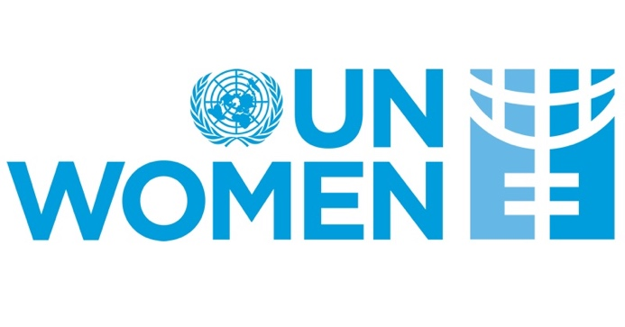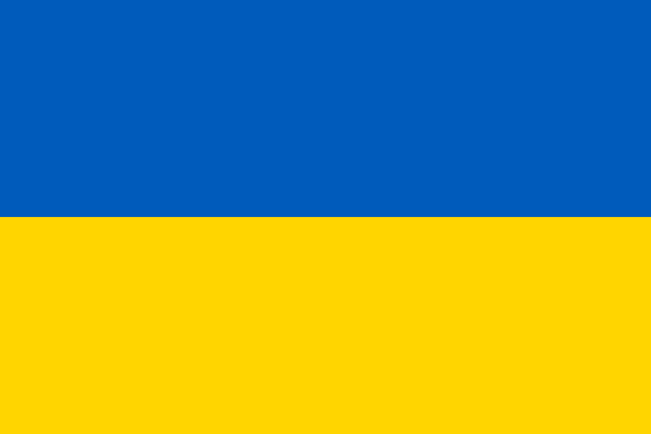

Country: Ukraine
Committee: UNWOMEN
Agenda: Gender Related Mobbing

Ukraine is honored and proud to take part in this committee on Gender Related Mobbing which can also contribute to the situation it is in. In this committee, we would specifically like to address the mobbing experienced by refugee women, including Ukrainian women, and to offer solutions against gender related mobbing.
Mobbing is defined as a form of human rights violation that involes psychological and physical pressure exerted on an employee by an employer or workforce to achieve a specific goal or to force an employee to quit. Although it is emphasized in various definitions that mobbing occurs regardless of gender, it can also be seen from sociodemographic variables that the reflection of gender roles on institutional relations may cause power inequality between male and female employees in the workplace. In this context, it is possible to say that women are exposed to mobbing more than men.
Ukraine has always been solid with their actions regarding this issue. With the studies carried out so far, Ukraine has made it an obligation to regulate mobbing and gender related mobbing with the aim to fight and protect the rights of employees against harassment, especially gender related harassment that they might face within their workplaces and impose administrative fines in order to prevent it happening. However, these projects and contributions currently can not be implemented due to war. Our women are unable to live a completely normal life because they moved to other countries as a refugee, running away from the war in hopes to find safety and balance in their life from the start, once again. Therefore, our work cannot give a comprehensive result.
Even though we are in bad times at the moment, we continue our latest works with great care. We want the committee, in which we will discuss the issues that need to be solved, to give good results both for the negative situations experienced by Ukrainian women at work and for all other women who are exposed to mobbing. We will be happy to share our country's policy and attitude in this direction with the committee.

Referances; https://www.researchgate.net/publication/348658201_Mobbing_as_a_form_of_discrimination_in_labor_relations_in_Ukraine_and_in_foreign_countries
https://en.m.wikipedia.org/wiki/Human_rights_in_Ukraine
https://dergipark.org.tr/tr/download/article-file/1355977
https://www.researchgate.net/publication/348658201_Mobbing_as_a_form_of_discrimination_in_labor_relations_in_Ukraine_and_in_foreign_countries

