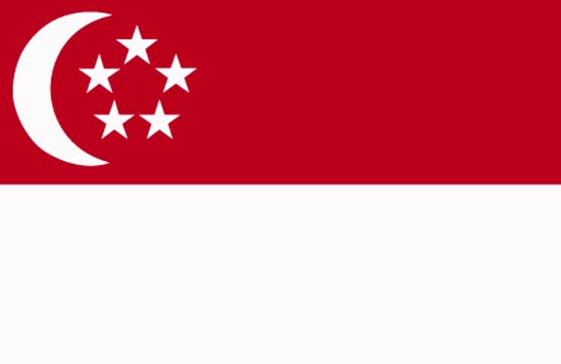
Country: Singapore
Committee: United Nations Development Program
Agenda Item: United Nations Sustainable Development
Goals 8 and 9

Singapore comprised of an island located in Southeast Asia; Strait of Malacca to the west, Singapore Strait to the south, South Chine Sea to the east and Straits o Johor to the north. Singapore has the third highest population density in the world. Our country’s main language is Malay, although English is the official language as well. Buddhists occupy the largest community (30%). Singapore’s population amounts to 5,637,000 citizens, of which 74% are Chinese, on a territory of only 773 km². Singapore is a member of the UN, WTO, East Asia Summit, Non-Aligned Movement and the Commonwealth of Nations. Because of the fact that Singapore is a city-state country, we have no capital. Singapore is a unitary dominant-party parliamentary republic. The president of Singapore is Halimah Yacob and the prime minister is Lee Hsien Loong.
In the 1960’s, Singapore’s population has grown up to 1.6 million. We had a small manufacturing infrastructure, limited know-how and financial capital, without possessing any remarkable natural resources. Singapore therefore adopted the import substitution strategy to accomplish these constraints. Several economic organizations like the Economic Development Board (EDB), which was established in 1961, and the Singapore Tourist Promotion Board in 1964 helped in improving the economy in different directions.
Singapore’s GDP increased 5.2% per annum in average between 1960 and 1964, whilst the share of the manufacturing sector was raised from 11% to 13%. In the next 14 years until 1978, the yearly growth of GDP even reached 10% whereas the manufacturing sector’s share achieved 24%. The main reason of that huge progress was the implementation of an export-oriented strategy which aimed to fascinate foreign investors for the development of the manufacturing and financial sectors. 2022 estimate of GDP per capita at the purchasing power parity is about US$ 132,000, which ranks it as the second of the world. The Human Development Index of Singapore is very high, namely 0.939.
Expansion in total employment has decelerated from 200,000 in year 2009 to 25,000 in 2015, because of the low birth rates and high labor force participation. Therefore, local workforce increase is expected to slacken in the next 10 years. Productivity grew by 2.5%, median wage by 2.6% p.a. between 2009 and 2016, and unemployment rate remained around 3%.
In 2010, Singapore has attempted to restructure its economy. In 2015, we created the Committee on the Future Economy, with an aim of helping the country to form new economic strategies by focusing on future markets, innovation, jobs and skills, urban development and infrastructure and connectivity.
To maintain economic performance, Singapore needed to shift from a manpower-based work to a productivity-driven approach. For this, Ministry of Manpower presented the “Adapt and Grow” initiative in 2016. The Professional Conversion Program aims to re-skill workers for some strategic industries; more than 24,000 individuals were able to find jobs through this initiative in 2017. As such, Singapore was claimed to be the world's most competitive economy in the World Economic Forum in 2019.
The Committee on the Future Economy has identified seven strategies which support each other, to acquire in-depth skilled workforce, innovative business, connected and renewing city, coordinated government.
Furthermore, the Singapore Tourism Board operates with industry, both to enhance the workforce capability and build local engagements.
Singapore has evolved its manufacturing, built up industries to face with the scarcity and lack of its natural resources. We found the innovation as a key of developing technological skills so we had made efforts to establish these skills. Public investment in R&D has grown from 2 billion dollars to 19 billion dollars, between 2016 and 2020.
Singapore has a very active container port, handling 33 million containers and linked to 600 global ports. Our airport let yearly 62 million passengers travel through 400 cities. These airports are planned to expand for serving additional 50 million travelers per year by 2030, and the railways will be enlarged from 230 to 360 kilometers.
Singapore also developed the internet and telecommunication services. In 2017, mobile phone penetration rate increased to 150% and wireless penetration rate to over 200%.
Singapore's innovations have risen in the last 25 years. We created A*STAR, the Agency for Science, Technology and Research. Singapore has improved biomedical sciences and engineering. We founded Biopolis and Fusionopolis in one-north district, a science park and hub supporting innovations. We hold 250 companies, 600 start-ups and 1600 scientists.
Singapore's small and medium-sized enterprises have entrusted most of the workforce (69%). Therefore they are backbone of Singapore's economy and they lend half to the GDP. They also increase foreign exchange because by attracting foreign costumers.
Throughout the world, especially in the less-developed countries like Turkey, there are not enough natural resources, airports, trade transportation. They are trying to overcome unemployment. But in the developed countries like UK and USA, workforce is matured. They have also developed a scientific background.
Although Singapore is a developed country, we still have to acquire deep capabilities and strengthen the already existed ones. We have to enable innovations, deepen International connections, establish strong digital skills and also improve its Industry Transformation Maps.
Globally, worker rights’ importance has to be understood. The law of the workers needs to exist in all the countries’ constitutions. Science should be cared so the innovations can be boosted. Scientists have to be supported.
The countries should manufacture their own products to export them. Therefore the innovations are significant because the innovations provide new products. GDP should be boosted and for that, export is really substantial.

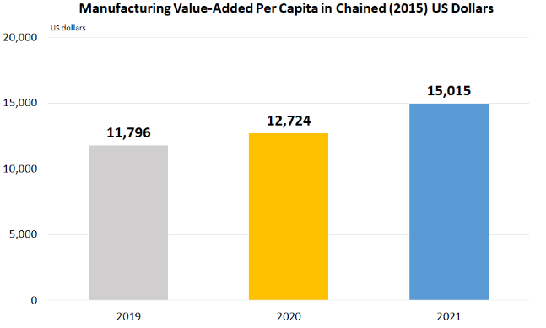
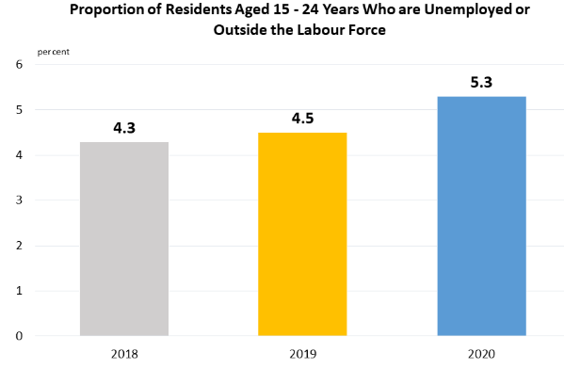

References:

- https://en.wikipedia.org/wiki/Singapore
- https://www.google.com/url?sa=t&source=web&rct=j&url=https://sustainabledevelopment.un.org/content/documents/19439Singapores_Voluntary_National_Review_Report_v2.pdf&ved=2ahUKEwi3xsbU5-b7AhXeiv0HHVLbBCIQFnoECCYQAQ&usg=AOvVaw21ScODHRSA8pJy8ihd5_kJ
- https://www.investopedia.com/terms/r/randd.asp
- https://ticaret.gov.tr/data/5b8a43345c7495406a227161/Singapur%20Bilim%20Park%20Biopolis-Fusionopolis%20ve%20Mediapolis%20K%C3%BCmelenme_2820129.pdf
- https://www.singstat.gov.sg/find-data/sdghttps://hdr.undp.org/system/files/documents/global-report-document/hdr2021-22pdf_1.pdf
- https://www.imf.org/en/Publications/WEO/weo-database/2022/April
- https://www.straitstimes.com/business/economy/singapore-is-worlds-most-competitive-economy-world-economic-forum

