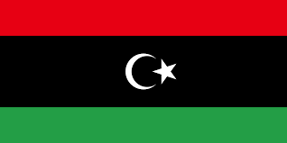
Country: State of Libya
Committee: UNWOMEN
Agenda Item: Gender Related Mobbing

The fourth-largest country in Africa, Libya is bigger than the state of Alaska. The country borders the Mediterranean Sea to the north, Tunisia and Algeria to the west, Niger and Chad to the south, and Sudan and Egypt to the east. State of Libya's capital is Tripoli. Libya is a participant in the OIC, OPEC, African Union,United Nations, the Arab League. The official language of Libya is Modern Standard Arabic.The current population of State of Libya is 7,137,931 .İn Libya between %90-%95 of the people are Sunni Muslims, %4.5-%6 are Ibadi Muslims, and the remaining individuals and small groups of Christians, Hindus, Baha'is, and Buddhists. State of Libya was under foreign rules for centuries until it gained independence in 1951.
Long before the Gaddafi government came to power, women in Libya actively contributed to the economic, social, and political growth of the nation. Women came together to form the first women's associations as early as 1955, but they suffered during the Gaddafi regime since total independence from the regime and its influence was not conceivable.
Women in Libya enjoyed the right to actively engage in social and political life prior to the Gaddafi administration, having gained the right to vote in 1920. The Great Green Charter of Human Rights in the Age of the Masses and the Declaration of the Authority of the People were both passed by Gaddafi in 1977 and 1988, respectively, but despite women being granted the same rights as men in areas like social security, help finding employment, and financial independence, these rights and freedoms suffered under the Gaddafi regime's growing civil rights restrictions. The situation of women in Libya was also discriminated against by conventional family laws, which disadvantaged women in matters of marriage, divorce, child custody, and laws against sexual assault.
In nearly 30 years, the female labor force in Libya has only increased by %7.4 . Males make up the bulk of the workforce in Libya. Men made up about 1.3 million of the workforce in 2019, compared to 627 thousand women. In comparison to 2010, the ratio of men to women did not increase much. The ratio generally stayed at 46 females for every 100 males. In 2020, Libya employed about 1.9 million adults who were 15 years of age and older.
To handle the increase in students, coeducational schools were constructed throughout east Libya. While there are still separate schools for boys and girls in West Libya, the government has regulated the curriculum to encourage students to select careers that would meet the country's current needs. A standardized curriculum helps all pupils compete on an even playing field. In Libya, the effects of these measures have been mainly positive for girls' education, but there is still a long way to go before real educational equality is achieved.
The Libya Status of Women survey indicated that 52 percent of Libyan women reached secondary education or above, compared to 53 percent of Libyan men. Similar levels of higher education are being attained by men and women, which will aid in the fight against gender economic inequality. In addition, compared to 67 percent of men, 77% of female students under the age of 25 said they planned to finish secondary school or higher.

The National Transitional Council released the Libyan Constitutional Declaration (Interim Constitution) in 2011, and it is currently in effect.Islamic Sharia is cited as the primary source of law in Article 1. Because of the Libyan Constitutional Declaration Libya is a profoundly patriarchal and paternalistic society with a strongly gendered division of roles in households, workplaces, and civic life, which is reinforced by law and policy. Media portrayals and school curricula reinforce disempowering gender stereotypes. On the other hand, female literacy and education levels are very high, and women’s rights advocates are active. Information on homes with a woman as the head, women's labor involvement, or women's income generating is scarce. About half of all instructors are women, and nearly all hired women work for the government in education, healthcare, or civil service management. Women have relatively few career prospects and little knowledge of their employment rights. Women who run their own businesses typically have very little access to government or bank loans, mentorship, or understanding about business regulations.
Mobbing is a serious issue in our world today. Mobbing is prevalent in areas like schools, companies, hospitals, and relationships, to name just a few. Mobbing can seem simple, yet it has a serious impact on us. It may pain you deeply inside even if you don't fully understand the situation. The most key point to remember is that mobbing is not based on gender. The statistically high proportion of women who experience mobbing suggests that it is gender-dependent. Results pertaining to gender disparities have frequently been erratic and ambiguous. Bullying incidents at work that are gender-related can vary by culture and nation.
Gender, however, can be said to have a significant and significant impact on mobbing. However, in the majority of research, mobbing victims are two thirds women and one third men. Women are more likely than men to experience mobbing, according to the majority of studies. The majority of research finding greater bullying rates for women utilized self-labelling as a way to quantify workplace bullying, while studies reporting higher bullying rates for males, albeit much fewer, often used the behavioral experience method, according to a pattern that can be seen.
The experience of women in the job market has always been substantially different from that of men. As highlighted in institutional reports (Equal Opportunities Committee of the European Commission, “flex-security” in the workplace and equal opportunities), women are subjected to daily acts of persecution and violence in family and social environments, especially women who have broken the mold of traditional “working stereotypes”.
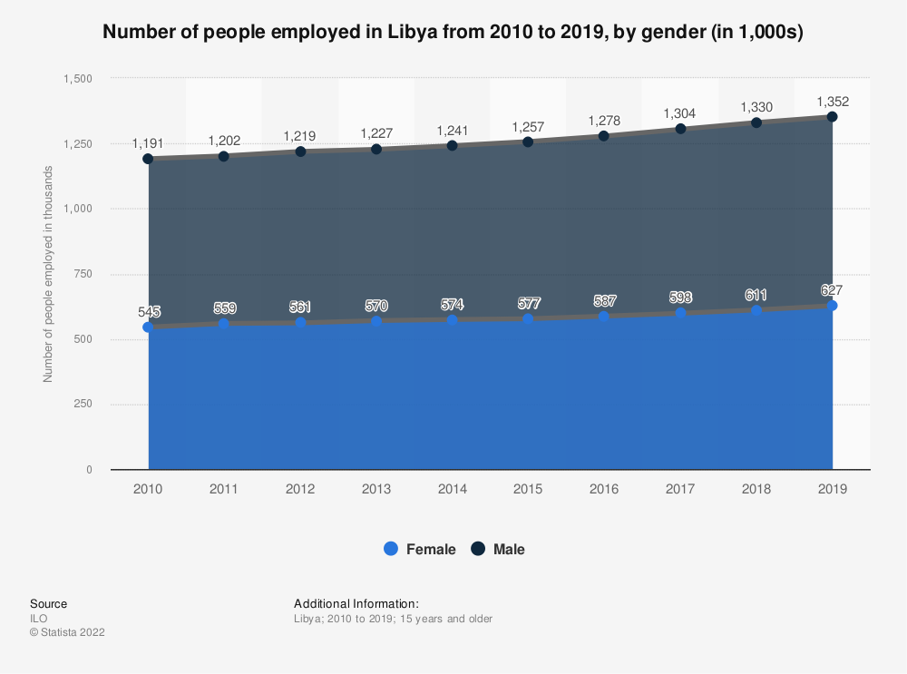

Mobbing should be made known to the public and brought to their attention. The general public has to be aware of the impacts and consequences of mobbing. and should be educated how to combat it. There should be research to erode gender roles. We believe that by working together, we can use our power to change the political and social climate in which we live. We are hopeful that the delegates present can help us solve this issue.

References:
https://en.wikipedia.org/wiki/Libya
https://www.statista.com/statistics/1235946/number-of-people-employed-in-libya-by-gender/
https://borgenproject.org/girls-education-in-libya/
https://www.ncbi.nlm.nih.gov/pmc/articles/PMC7926862/
https://data.worldbank.org/indicator/SL.TLF.TOTL.FE.ZS?locations=LY
https://www.cia.gov/the-world-factbook/countries/libya/
http://www.genderconcerns.org/country-in-focus/libya/the-situation-of-women-in-libya/
https://www.constituteproject.org/constitution/Libya_2011.pdf
https://pdf.usaid.gov/pdf_docs/PA00WRDD.pdf
https://www.britannica.com/place/Libya
https://www.state.gov/reports/2021-report-on-international-religious-freedom/libya/#:~:text=Sunni%20Muslims%20represent%20between%2090,of%20whom%20are%20mostly%20foreigners.
https://www.un.org/en/about-us/member-states/libya#:~:text=On%2022%20December%202017%2C%20the,to%20%E2%80%9CState%20of%20Libya.%E2%80%9D

