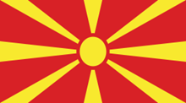
Country: Republic of North Macedonia
Committee: United Nations Entity for Gender Equality
and the Empowerment of Women
Agenda Item: Gender Related Mobbing

North Macedonia is a landlocked country in the balkans and borders Serbia and Kosovo on the north, Albania on the west, Greece on the south and Bulgaria on the east. The capital of the country is Skopje. North Macedonia gained its independence from Yugoslavia in 1991 under the name of Macedonia. It is a member of UN, NATO, the Council of Europe, the World Bank, OSCE, CEFTA, BSEC and the WTO. The population is approximately 2.065.000 citizens. The offical languages of the country are Macedonian and Albanian. The form of government is parliamentary republic and the President of the country is Stevo Pendarovski. And Dimitar Kovačevski is the Prime Minister of North Macedonia.
Gender equality is a very important factor in the development of a society. It increases productivity and ensures peace. For these reasons, in 2020 Friedrich Ebert Foundation in North Macedonia decided to devolop and conduct a women’s study, in order to measure,describe and explain the status of the female population vis-a-vis society,family,values,education,employment,politics,security and healthcare. The study was created based on our knowledge gained from conducting in-depth youth studies in 2014 and 2019, which were well accepted in the nation and in the area and served as the foundation for formulating policies and projects in previous years.
Also, mobbing is a very restrictive thing. Because when someone is exposed to mobbing, she closes herself and becomes unable to do the things she can do. Because of that reason it can sometimes be politically restrictive for women. In order to prevent this situation, North Macedonia organized a roundtable meeting on 01.12.2022. The topic of this meeting was “Amendment and addition of the electoral law to increase the participation of the less represented gender in the electoral lists from 40% to 50%.By increasing the number of deputies and councilors at national and local level to 50%, women's representation in the Assembly will reflect the demographic situation in the country. In addition, in this way, the power and influence of women MPs in creating appropriate regulations and proposals will be strengthened.
Recently (22.09.2022) the "Gender Equality at Work" Conference was held by the Center for Change Management under the auspices of Elizabeta Gjorgievska, the wife of the President of the Republic of North Macedonia. Particular attention was paid to the panel on Creating better workplaces by achieving gender equality, where representatives from Pivara, TIRZ, Philip Morris and GEA presented their experiences, situations and presentations on treatment of employees and gender equality in companiesAt the conference, MTSP representative Natasa Dimeska spoke about active measures towards the employment and care economy, which are difficult to employ in the labor market and that allow older women to have the opportunity to find work and earn.

Deputies Club President Lolita Ristova gave a speech at the Forum "Political Mobbing - Part Mobbing Law" organized by LAG Agro Leader and with the support of NDI Macedonia on October 5, 2022. Women and men led the way. Deputies spoke on a variety of topics, and President Ristova gave a speech at the "Women in politics and their influence" session. Representatives from the judiciary and legal professions present at the forum referred to the national legislation and judicial processes regarding the proof of mobbing, and it was concluded that in order to prove whether there is mobbing or not, it should first be determined whether there is mobbing or not. This situation shows that North Macedonia attaches importance to prevention of mobbing.
The Deputies Club of the Assembly of the Republic of North Macedonia held a meeting on March 10, 2022 with the Deputies of the Parliament of the Republic of Kosovo to share parliamentary practices: "The way from ratification to implementation of the Istanbul Convention". With the ratification of the Istanbul Convention in December 2017, the Republic of North Macedonia has committed to take legislative and other measures to provide a legal, institutional and organizational framework for the prevention of violence against women and the protection of victims of violence. In October 2018, the Government adopted the five-year National Action Plan for the implementation of the Council of Europe Convention on Preventing and Combating Violence against Women and Domestic Violence (2018-2023). A national coordinating body has been established for the implementation of the Council of Europe Convention on Preventing and Combating Violence against Women and Domestic Violence.
Republic of Northern Macedonia held a joint working meeting with the representatives of the Local Coordination Board for Protection Against Discrimination - Štip Municipality on 31.10.2022 within the scope of the "Report Mobbing, Don't Be Silent, We Are Not Equal to Mobbing" project. At the working meeting, the promotion of joint initiatives and actions with the institution in order to improve the rights of workers and women, as well as issues related to gender-based discrimination and mobbing were discussed.
One of the reasons for mobbing is gender discrimination. For this reason, an online survey was conducted on gender discrimination in North Macedonia. These are the results of this survey. (63% of respondents had high education, 73% were full-time employed and75% were younger than age 39) More than half of the online survey participants (68%) agreed that genderbased discrimination is against the law. More than every tenth (13%) thought it is not and nearly every fifth (19%) did not know.
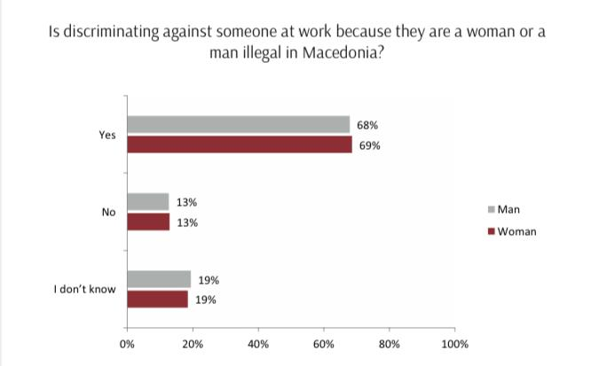

In the Republic of Macedonia in the period from 2007-2014 year several researches on mobbing are conducted by several organizations, unions, institutions, scientific institutions, NGOs and others. One of the first researches that were conducted in the country about the presence mobbing is a survey of the Federation of Trade Unions of Macedonia in 2007 and 2008 through a survey which polled 510 respondents. Moreover, 41% said they were victims of mobbing, 30% that suffer because of political pressures, 40% said that they have serious health problems as a result of the pressures they experience in the workplace.
The Assembly of the Republic of North Macedonia, organized by the Deputies Club with the support of UnWomen, participated in the "16 days of activism against gender-based violence" celebrations. The United Nations family, the European Union and the OSCE Mission in Skopje have traditionally joined forces for 16 days of activism against gender-based violence, a campaign to end violence against women and girls. North Macedonia's "To end violence against women and girls, paint the world orange now!" The slogan of this year, which he participated in the global campaign, is "Don't be silent, don't endure, DO NOT END!" it happened.
Women can also be subjected to violence and harassment in the workplace. This has a huge impact on women's working life. In the image below, the rate of violence and harassment experienced by women in the workplace is given by country.
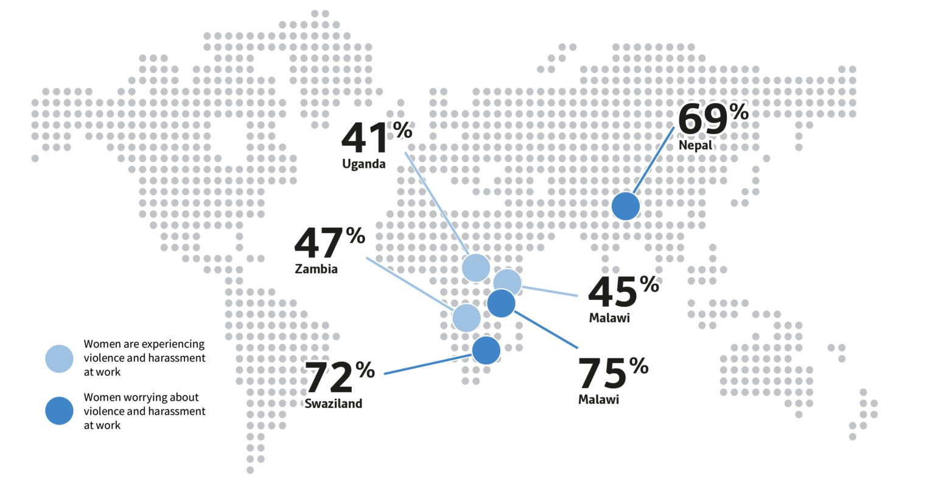
Women across the world who cited violence and harassment as a source of risk to their personal safety while working, and those who have experienced, or know someone who experienced, this issue at work in the two years prior to polling. (% country female workers)
Mobbing is very serious problem in the world. It affects people physically and psychologically. It can causes irreversible things. Because of that reasons we have to take precaution. We should teach what mobbing is to people who don’t know.Legal penalties should be given to people who mobbing another people. Women should educate more. The results of mobbing should be shown to the people working in the workplaces and awareness should be created. With this precautions we can reduce mobbing rates.
REFERENCES:
https://www-sobranie-mk.translate.goog/ns-newsarticle-politicki-mobing-del-od-zakonot-za-mobing.nspx?_x_tr_sl=mk&_x_tr_tl=tr&_x_tr_hl=tr&_x_tr_pto=sc

https://www-sobranie-mk.translate.goog/KaSOZ/aktivnosti-3e658721-eeaf-413b-bca1-5f4126db801b-ns_article-ne-molci-ne-traj-stavi-kraj.nspx?_x_tr_sl=mk&_x_tr_tl=tr&_x_tr_hl=tr&_x_tr_pto=sc

https://www-sobranie-mk.translate.goog/KaSOZ/aktivnosti-3e658721-eeaf-413b-bca1-5f4126db801b-ns_article-sredba-na-klubot-na-pratenicki-so-pratenicki-od-kosovo-10-3-22.nspx?_x_tr_sl=mk&_x_tr_tl=tr&_x_tr_hl=tr&_x_tr_pto=sc

file:///C:/Users/ececivelek/Downloads/ENstudy.pdf

https://www-sobranie-mk.translate.goog/ns-newsarticle-trkalezna-masa-za-zgolemeno-ucestvo-na-zenite-na-izbirackite-listi.nspx?_x_tr_sl=mk&_x_tr_tl=tr&_x_tr_hl=tr&_x_tr_pto=sc

https://glasentekstilec-mk.translate.goog/2022/10/31/%D1%80%D0%B0%D0%B1%D0%BE%D1%82%D0%BD%D0%B0-%D1%81%D1%80%D0%B5%D0%B4%D0%B1%D0%B0-%D1%81%D0%BE-%D0%BF%D1%80%D0%B5%D1%82%D1%81%D1%82%D0%B0%D0%B2%D0%BD%D0%B8%D1%87%D0%BA%D0%B8%D1%82%D0%B5-%D0%BD%D0%B0/?_x_tr_sl=mk&_x_tr_tl=tr&_x_tr_hl=tr&_x_tr_pto=sc
file:///C:/Users/ececivelek/Downloads/Gender-based-discrimination-in-N.Macedonia-EN.pdf
https://eprints.ugd.edu.mk/11645/1/THE%20LEGAL%20ASPECTS%20OF%20THE%20MOBBING%20IN%20THE%20REPUBLIC%20OF%20MACEDONIA.pdf

https://wrp.lrfoundation.org.uk/2019-world-risk-poll/women-across-the-world-fear-violence-at-work/

.

