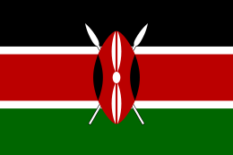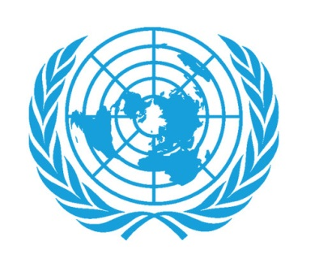 Country: Kenya  
Committee: UNWOMEN  
Agenda Item: Gender Related Mobbing

Mobbing, as a sociological term, means bullying of an individual by a group. Which can be seen like, psychological violence, oppression, siege, harassment, inconvenience or distress. The most expressive meanings are intimidation or psychological terror at work. As shown in Graph 1 women experience mobbing incidents more frequently than men in most countries of Europe. For this reason, it is possible to say that gender is one of the main causes of mobbing.

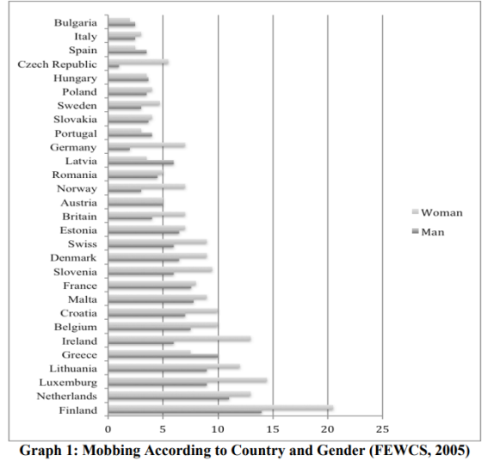

UN Women is committed to promote gender equality and the empowerment of women worldwide while delivering green results, with an emphasis on transparency and effectiveness. UN Women has 41 member states including Kenya

The key areas of gender inequality in Kenya are the health and education sector, Economy and work. These are the areas in Kenya were women and men lack equal opportunites . As an example in 2015 when they made the first-ever United Nations Environment Assembly, that took place in Nairobi, Kenya. They found an unfinished agenda For instance, UNICEF estimates that across 25 Sub-Saharan African countries women spend a combined total of at least 16 million hours each day collecting drinking water (compared with men’s six million hours). In many regions, women’s care work includes water use and management: cooking, cleaning, and laundry, which all require fetching and hauling water.

It ranks 154 out of 177 countries in 2005 Human Development Index. In 2021 the government of Kenya took co leadership of the Generation Equality movements Action coalition to end gender based violence . On the other hand since 2019, with support from the Government of Italy, UN Women Kenya and UN Human Rights have been working in Western Kenya and Nairobi on prevention and response mechanisms to reduce violence against women during elections.

Wangechi Kahuria, UN Women expert in Kenya, explains that “one of the critical components of the project is to empower the community in sexual and gender-based violence response. They are often the first responders and should therefore be equipped to deal with case. This means training [them] on responding to survivors, understanding the referral pathways from a legal perspective, but also ensuring that human rights defenders have the support they need, to avoid burnout.” As a result, the Project has trained more than 38 human rights defenders in Western Kenya and Nairobi, and 555 survivors have accessed legal aid and psychosocial counselling in 2020.

Sources:

* <https://www.unwomen.org/en/news-stories/feature-story/2021/11/believe-survivors-act-now-gorettis-story-kenya>
* <https://www.unwomen.org/en/news/stories/2014/7/lakshmi-puri-oped-on-women-and-the-environment>