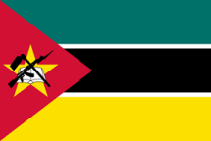
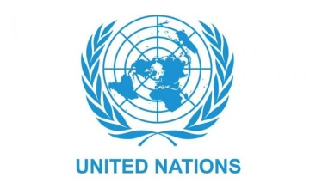
Country: Republic of Mozambique
Committee: United Nations Development Programme (UNDP)
Agenda Item: Sustainable Development Goals 8 & 9
Delegate: Elif Seniz Sen

Our country, The Republic of Mozambique, is located in southeast Africa. The official language in Mozambique is Portuguese. The most commonly used languages are Makua, Sena and Suahili. The capital is Maputo, the President is Filipe Nyusi, and the Prime Minister is Adriano Maleiane. At the Berlin Conference held in 1885, Portugal stated that it had annexed the territory of Mozambique to its protectorate, and in 1924 Portugal took the entire territory of the country under its control. Since the 1930s, workers have started to be brought to the region from Europe to be employed, and in 1951 Mozambique was granted the status of an overseas province of Portugal.
Sustainable economic growth includes long-term growth. Long-term growth, on the other hand, can occur with an increase in the quantity of production resources or an increase in productivity and quality.
Target 8: Decent work and economic growth the amount of income per capita in 8.1 was realized as 500 dollars / year in our country in 20/21. While GDP should be at least 7% annually in accordance with international conditions, the GDP per capita rate in our country in 2001 was realized as 2.2%. This shows that the targeted growth rate has not been achieved.
8.4 it is aimed to conclude the resource increase in consumption and production by 2030 in accordance with the 10-year framework program without disturbing the environment. The targets set in our country before 2020 have not been achieved. The reasons of this failure are the economic uncertainties, the high tax rate and the unofficial / unregistered economy. The unofficial economy represents 26% of the whole economy. If the unregistered economy is taken under control, it might be possible to achieve the country’s goal. It is crucial to create an environment in which the employees can work in a safe and healthy environment without risking their physical and psychological health while ensuring their employment and to make it sustainable. In order to ensure and promote decent business ideology, the cost of production can be reduced, cheap raw materials and labor can be provided by providing tax breaks to the entrepreneur. Part of the energy production used can be covered by the state.
Target 9: Industry, Innovation and Infrastructure are covered.
It will be possible to support inclusive and sustainable industrialization and to harmonize the employment and gross domestic product share of the industry with national conditions by 2030 by providing energy resources. Although Mozambique has a great potential in the field of energy, only 34% of the country's population has access to electricity. The insufficiency of the existing electricity distribution network in the country and the very slow progress of new energy projects due to bureaucracy are the main factors in keeping this percentage low.

