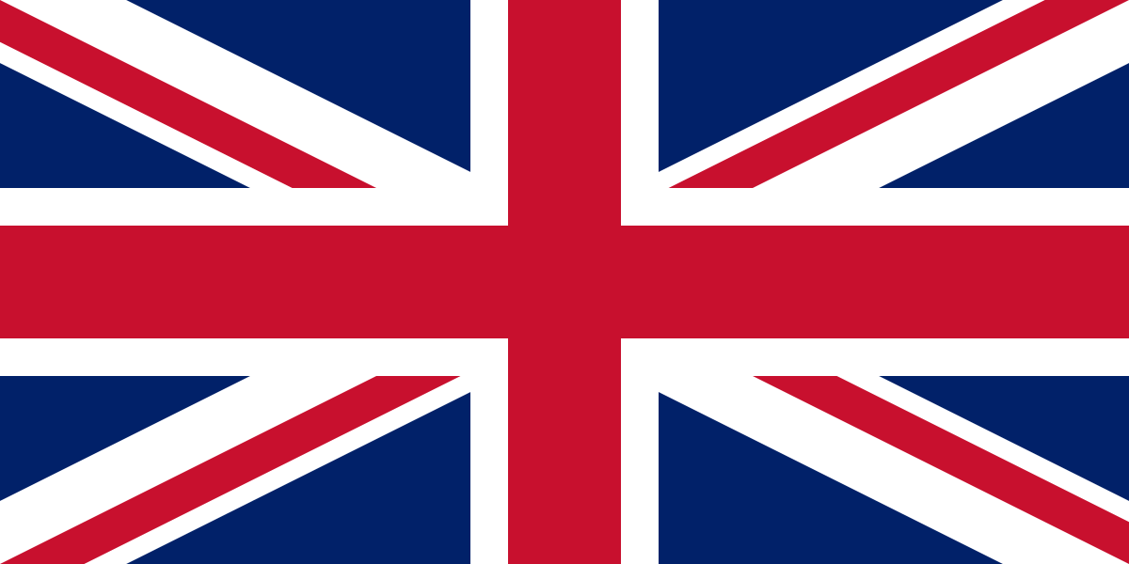United Kingdom of Great Britain and Northern Ireland

United Nations Office on Drugs and Crime

Modern Human Trafficking in Arabian and Aftrican Region

In the United Kingdom of Great Britain and Northern Ireland, usage of drugs until 1916 was hardly controlled and some kind of drugs are available and accessible for people. However, after WW1 troops began to use drugs and in the following years this situation raised anxiety in the society. So, United Kingdom started to implement more control over drugs. A system called "British System" is developed and after this system, everyone would be punished and criminalized other than the drug addicts' doctors. Yet this was not enough to prevent people from using drugs so, government take a bunch of actions during time.

The United Kingdom of Great Britain and Northern Ireland sees the usage, producement, sale, supply, import or export as a crime. It is strictly forbidden in the country. Neverthelater, the punishment and implemented sanctions are differ from each other. The UK has "The Advisory Council on the Misuse of Drugs (ACMD)" and this council differs those drugs by taking their risk for people into consideration. The United Kingdom also have an act named "The Psychoactive Substances Act" to criminalize the usage and production of drugs.

The United Kingdom of Great Britain and Northern Ireland got a policy that's different from many countries in these days. However, keeping the things that creates risk for people and harms them have to be strictly forbidden. The delegation of United Kingdom is going to be support this idea. Decriminalization of drug usage may be beneficial at some points but United Kingdom thinks that a good education and raising awareness would be a lot more beneficial than decriminalizing it.

So, the United Kingdom thinks that education and awareness is the key to decrease the rate of drug usage and abuse not decriminalizing it. With that being said, the United Kingdom will be always support and promote the ways other than decriminalizing it and share their ideas about how we and humanity get the advantages of criminalizing the drug usage and production. The newest differential rates on drugs may cause to review our policies in the long term but at present, the United Kingdom take a stand against decriminalization of drugs.