COUNTRY: Germany
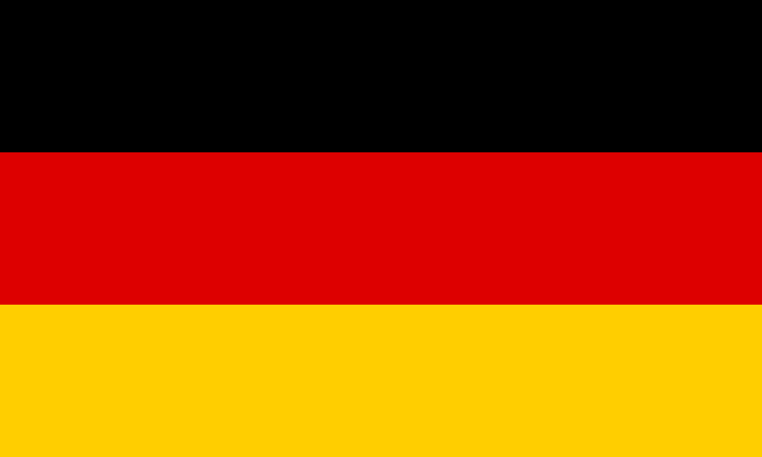
TOPIC: Achieving Sustainable Development Goals 8 and 9
COMMITTEE: United Nations Development Programme (UNDP)

Position Paper
Germany, officially the Federal Republic of Germany is the seventh-largest country in Europe covering an area of 357,022 square kilometres (137,847 sq mi), with a population of almost 84 million within its 16 constituent states. Germany is located between the Baltic and North seas to the north, and the Alps to the south. We cannot skip the fact that the economy of Germany is a highly developed social market economy.It has the largest national economy in Europe, the fourth largest by nominal GDP in the world, and fifth by GDP (PPP). Also, Healthcare spending in Germany exceeds €400 Billion (2019), not including expenditure for wellness and fitness. The market has grown at a rate of 4.1% over the past 10 years. With more than 7.5 million employees and exports in excess of €126 billion, healthcare is one of the largest economic sectors in Germany.
Focusing on the Goal 8 and Goal 9, which are Decent Work and Economic Growth; Industry, Innovation and Infrastructure, Germany remains the European Union’s most politically and economically influential member nation. Germany’s solid economy, the world’s fourth largest and Europe’s largest, is based on exports of high-quality manufactured goods. Germany’s economic freedom score is 76.1, making its economy the 16th freest in the 2022 Index. In order to continue to safeguard the viability of Germany’s economy, the government is strengthening private sector and public sector investment in Germany and Europe. Investment and innovations are key to higher competitiveness, lasting prosperity and a better quality of life. Regulatory and accounting systems are complex but fair. Infrastructure is reliable, and the social climate is attractive. Germany ranks seventh among the 27 EU members for average labor cost. Labor laws make the hiring and dismissing of employees problematic. Inflation in historically fiscally and monetarily conservative Germany rose significantly to nearly 3 percent in 2021, partly because of sharply rising natural gas prices across Europe. The top individual income tax rate is 47.5 percent, and the federal corporate tax rate is 15.8 percent (effectively above 30 percent with other taxes). Fair mobility is important to Germany. German labour law also applies to harvest workers. This includes entitlement to paid holiday, payment in lieu of untaken holiday, continued payment of wages in the event of illness, and much more. The German Government's new transport investment strategy will see increased spending until 2030. The Ministry for Transport says that the emphasis will be on renovating existing infrastructure, instead of building new projects. Around 70% of investment will be for renovation and improvement projects, compared to 56% in the previous transport strategy. The plan is worth a total of €264.5 billion, an increase of €91 billion over the previous plan, with 49.4% targeted at road projects, 41.3% for rail and 9.3%.
In order to develop Decent Work and Economic Growth; Industry, Innovation and Infrastructure all around the world without discrimination, we can send experts from the countries which have the good Economy, Decent Work and Industry to the underdeveloped countries to observe the gaps to fill and make a project with the help of UN and under the surveillance by them.

References:
Economic forecast for Germany (europa.eu)
German Economy: Facts, Population, GDP, Inflation, Unemployment, Business (heritage.org)
Living and working conditions: Germany (europa.eu)
Innovation in Germany (gtai.de)
Germany GDP Annual Growth Rate - 2022 Data - 2023 Forecast - 1971-2021 Historical (tradingeconomics.com)
Germany is developing infrastructure plans | World Highways

