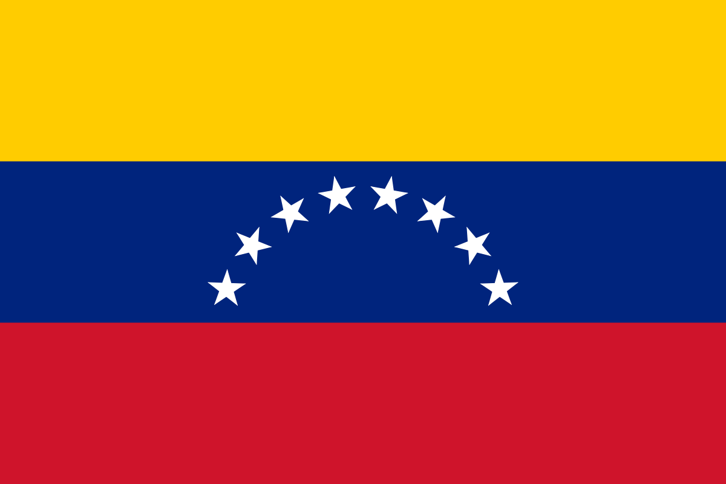

COMMITTEE: UNWOMEN
COUNTRY: Venezuela
AGENDA ITEM: Gender Related Mobbing

Mobbing is defined as a psychological harassment that is systematically applied by an individual or a group of people against another person in an unethical and advise way in a workplace or elsewhere. The interest in the problem of mobbing has not ceased for several decades, nowadays mobbing has become one of the most serious psycho-social hazards in the society and it has been confirmed that it has serious effects on psychical and psychological health. The problem of mobbing is actually not something based on gender, however we can say that gender has an important role in mobbing. Although gender was not found to be a major factor for being chosen as a target, it intensifies the negative consequences for women through the mobbing process and afterwards, in work life, private life and social relations. Men are generally exposed to mobbing by men, and women are generally exposed to mobbing by both men and women. The biggest reason for this is that female leaders are more likely to be selected for positions associated with poor performance than men and men are more likely to be selected and eligible for positions associated with successful performance than women. As a result of this study, it is observed that gender significantly influences women’s mobbing experiences.
Venezuelan government’s public policies regarding the rights of women and the use of information communication technologies (ICT) and legal instruments that enable empowerment and gender equality in Venezuela. It also discusses the discrimination against women in public institutions and considers some incidents where the use of the internet and ICTs is promoted gender violence – but likewise it has created opportunities for citizen participation and women in protest. In Venezuela, public policies related to ICTs do not include a gender perspective, but there are tools that facilitate the inclusion of women in the work of the country, seen in the “visibility” of women’s rights. Particular incidents are analysed, including citizens and public officials who were exposed to persecution for political reasons and layoffs in various public agencies between 2004 and 2013. It identifies cases of mobbing in the period 2006-2010, and looks at the impact of ICTs on these incidents. With regard to the participation of women in the defence of their rights, in recent years different types of opportunities have been created in our country. In particular, a number of civil society groups have used the internet to establish mechanisms to defend women’s rights, inform, educate and denounce gender violence.
As Venezuela we are aware that people and societies need to learn more about this issue so we think that raising awareness and informing people is the key to solve the mobbing problem.
We determine to take some action towards recognising women’s rights using ICTs,the internet and list a series of recommendations to do with employment discrimination against women in Venezuela.This is an indication of mobbing and the participation of women in online spaces and conferences will show the importance of ICTs, promotion and dissemination of information that seeks to open spaces for the defence of their rights.

