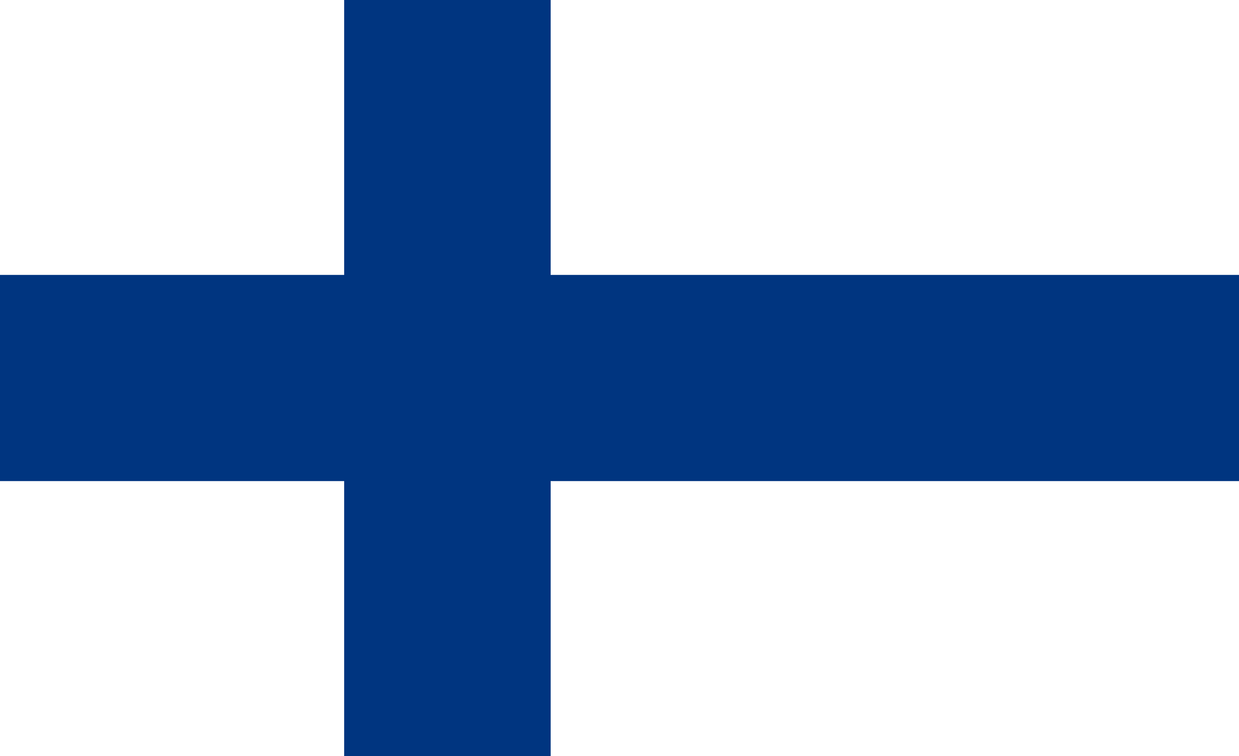

COUNTRY: FINLAND
COMMITTEE: UNWOMEN
AGENDA ITEM: GENDER RELATE MOBBING
DELEGATE: SEVGİ ÖZBEGE

The republic of Finland is a state with an area of ​​338,145 square kilometers and a population of 5,601,000. Although the literacy rate has been 100% since 2000, employment is quite high. Finland was a province and then a grand duchy under Sweden from the 12th to the 19th centuries, and an autonomous grand duchy of Russia after 1809. It gained complete independence in 1917. In the 21st century, the key features of Finland's modern welfare state are high-quality education, promotion of equality, and a national social welfare system.Our women's history of success dates back to 1906. . Women citizens of Finland, who received the right to vote and to be elected in 1906, started working early because of this. The prime minister is currently a woman. In addition, 93 of the 200 ministers of the parliament are women. this is the best reflection of the position of women in the country. The fact that schools do not force children and provide education in a way that will improve themselves is very effective in raising conscious and competent individuals.

According to the 2018 gender equality report announced by the World Economic Forum, Finland ranks fourth among 149 countries in gender equality. In accordance with the Finnish amendment law, we are looking for a stability plan requirement in the workplace where more than 30 people are employed. At the same time, the mother is entitled to 105 days of leave after birth, and the father is entitled to 18 days. After this leave, parents can take any 158 more days off. In addition to this leave, parents can take unpaid leave without the condition of leaving a job until the child reaches the age of three. Also, directing any work to paid units reduces taxation.

Finland, which has adopted the equality of women and men, is trying to eliminate the difference between men and women in business life. Women make up 47.9% of the workforce, so women and men are intertwined in many sectors.Although we are against all forms of mobbing, we are doing a lot of work in our country to prevent gender-related mobbing, especially the Kiva (anti-bulling) program. just one. In 2015, more than 40 nonprofits provided online services to more than half a million victims. We started to create a 24/7 online line for mobbing. We trained 200 judges for mobbing. We do not want people to reflect the negative aspects of mobbing results individually or socially. Instead of people with anxiety and depression, we want people who are conscious of bullying and have a high level of education to enter the working life. Let's not forget that every citizen has the possibility of being bullied as well as being bullied. Supporting the working life of women and men will become easier with the influence of the state and organizations.

