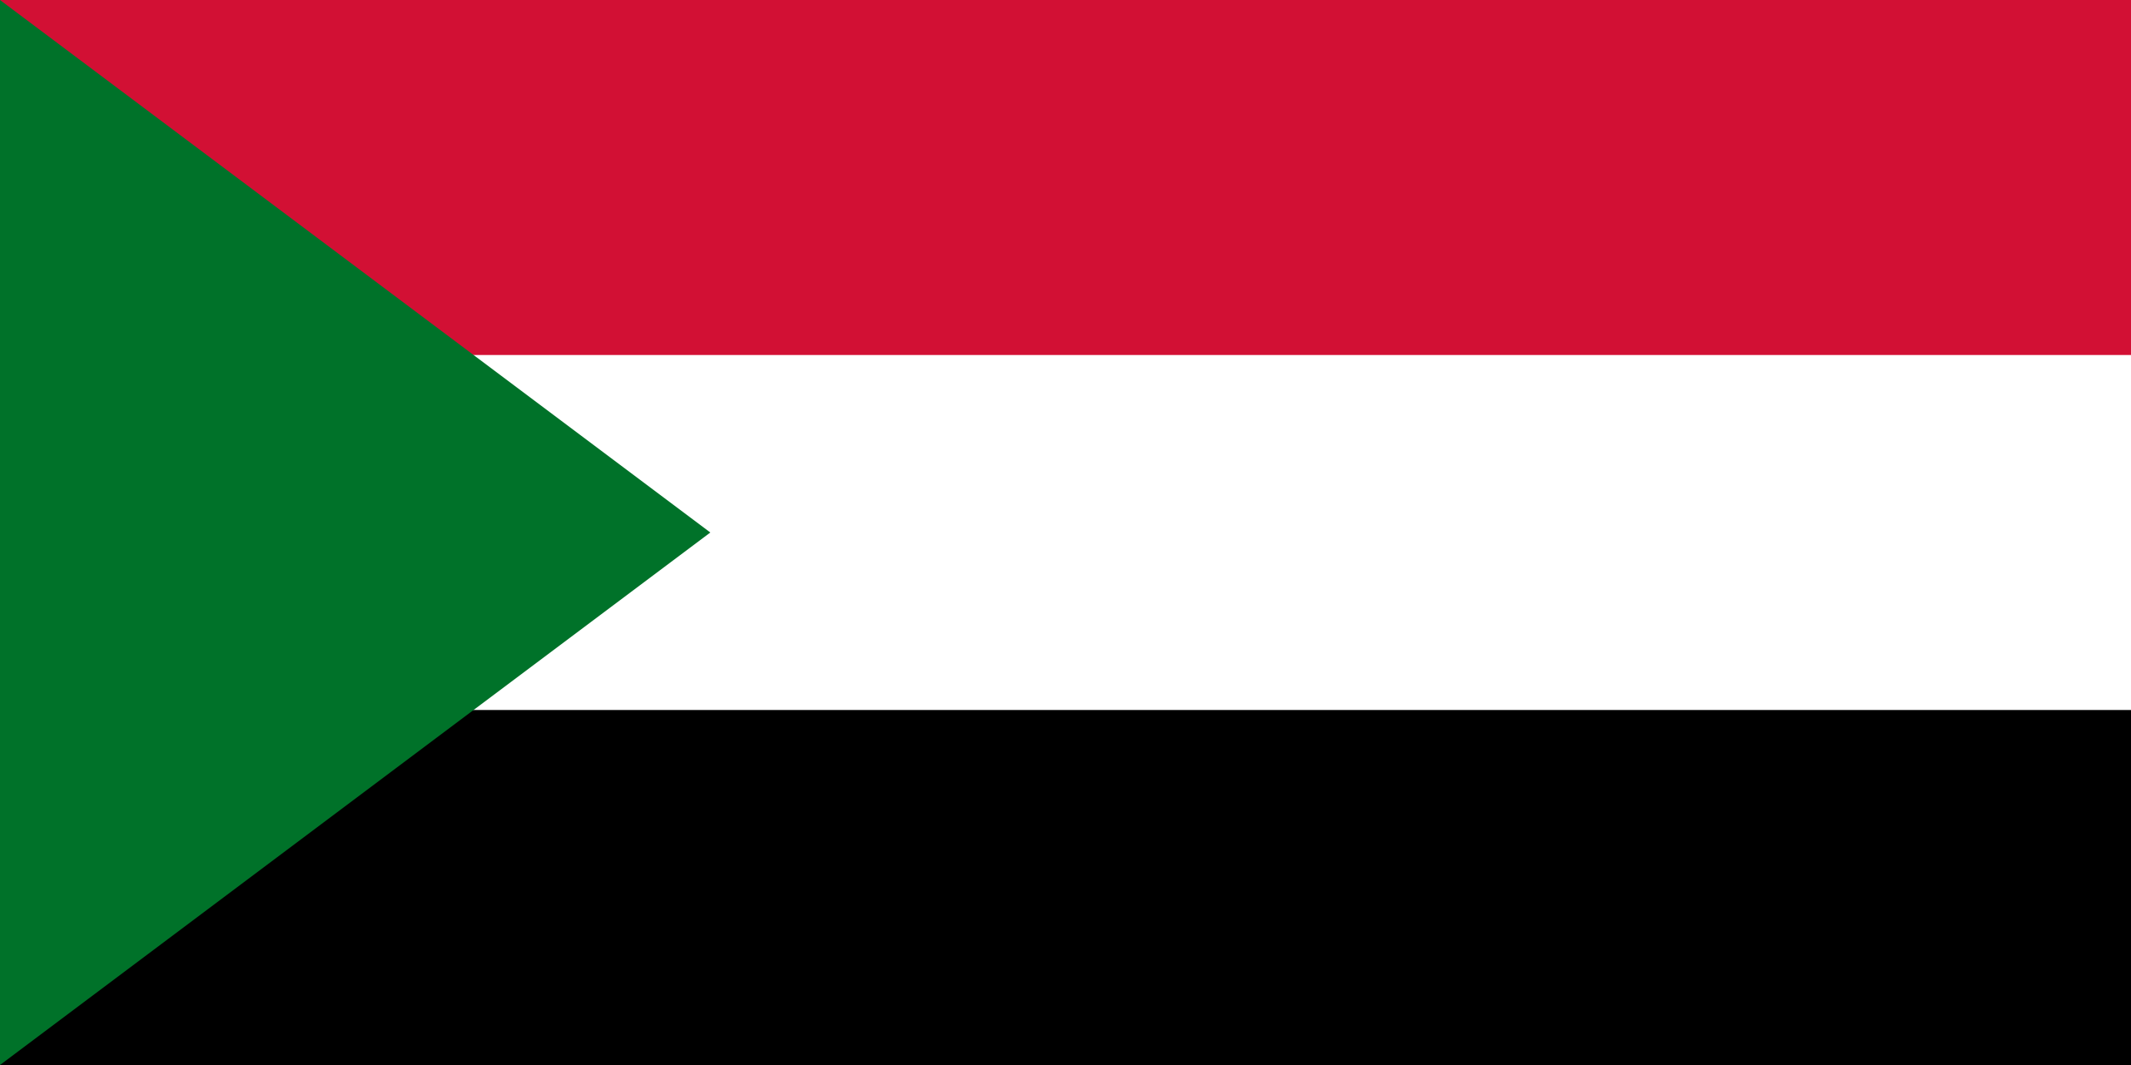
Country: Sudan
Committe: UNDP
Agnenda Item: Sustainable Development Goals 8 & 9

Republic of Sudan is the third largest country in Africa with a population of 47 million. It is located in North Estern Africa, bordering the Red Sea between Egypt and Eritrea. Sudan gained its indepence in 1956 from the Aglo-Eyptian Condominium and British Goverment. It occupies 1,886,068 square kilometres (728,215 square miles), making it Africa's third-largest country by area, and the third-largest by area in the Arab League. Its capital is Khartoum and most populated city is Omdurman.

Sudan is also one of the richest countries in Africa in terms of natural resources such as minerals, gold, agricultural lands, and forests. Despite these natural resources that Sudan contains, many problems are facing the exploitation of these resources, including the economic sanctions imposed on Sudan twenty years ago, which has harmed development in Sudan. Sudan suffered for decades from civil wars that killed about one and a half million people. In 2011, the civil war ended with the secession of southern section. After the separation of South Sudan in 2011, the population decreased from 50 million to 40 million.Also Sudan has experienced protracted social conflict and the loss of three quarters of its oil production due to the secession. The oil sector had driven much of Sudan's GDP growth since 1999.

The Sudanese economy has experienced slow or negative growth over the past five years .Sudan is attempting to develop non-oil sources of revenues, such as gold mining and agriculture. Agriculture production remains important, because it employs 80% of the work force and contributes a third of the GDP. We are also carrying out an austerity program to reduce expenditures. The world’s largest exporter of gum Arabic, Sudan produces 75-80% of the world’s total output.

As a developing country, Sudan needs to accelerate progress to wards achieving all SDGs (Sustainable Devolopment Goals)of the United Nations 2030 Agenda. On its current situation, quicker progressis essential on all levels and fronts. Given Sudan is a country living with armed conflict, injustice and authoritarianism, Sudan`s civil society organisations were highly motivated to work on SDG16.

Recently, number of primary agreements have been signed between the government delegation and some of the armed groups particularly the revolution alliance and have identified some priorities. Therefore, the national transitional government should pay great attention to the alignment of its policies, processes and plans with structural arrangements undertaken to achieve progress in SDG16.

REFERENCES:
https://www.ressjournal.com/Makaleler/878193203_12_Adam%20Mohammed%20Hussein.pdf
https://www.cia.gov/the-world-factbook/countries/sudan/#geography
https://en.wikipedia.org/wiki/Sudan
https://www.socialwatch.org/node/18514

