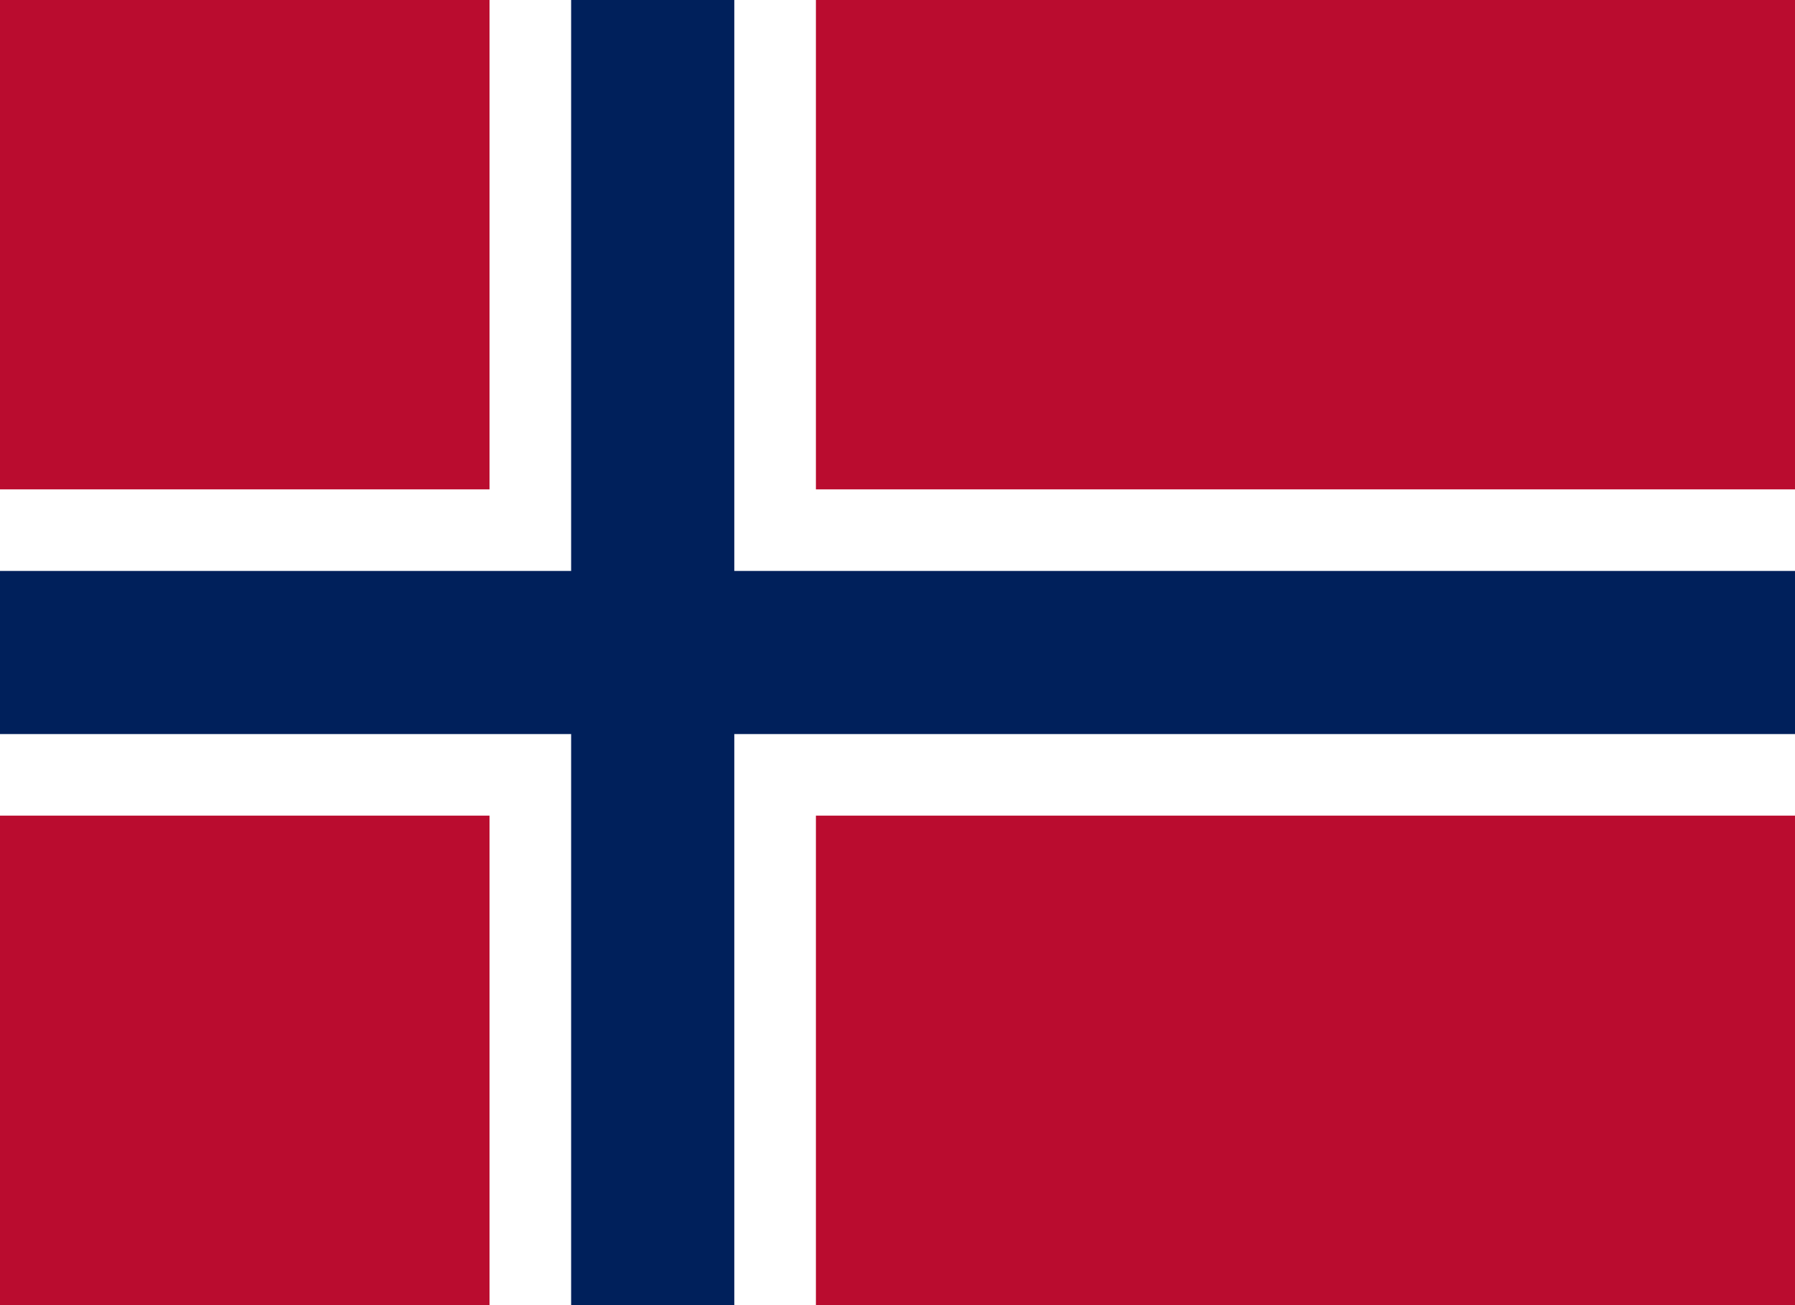
Committee: NATO
Agenda Item: Nato’s Indo-Pacific Involvement
With Regard to the 2022 Strategic Concept
Country: Norway
Norway, officially known as the Kingdom of Norway, is a Nordic country in Northern Europe, the mainland territory of which comprises the western and northernmost portion of the Scandinavian Peninsula. It is bordered by Finland and Russia to the northeast and the Skagerrak strait to the south, on the other side of which are Denmark and the United Kingdom. It’s capital and the largest city is Oslo. Norway has a total area of 385,207 square kilometers and had a population of 5,425,270 in January 2022. The maritime influence dominates Norway’s climate, with mild lowland temperatures on the sea coasts; the interior, while colder, is also significantly milder than areas elsewhere in the world on such northerly latitudes.
Two centuries of Viking raids into Europe tapered off following the adoption of Christianity by King Olav Tryggvason in 994; conversion of the Norwegian kingdom occured over the next several decades. In 1397, was absorbed into a union with Denmark that lasted more than four centuries. In 1814, Norwegians resisted the cession of their country to Sweden and adopted a new constitution. Sweden then invaded Norway but agreed to let Norway keep its constitution in return for accepting the union under a Swedish king. Approximately 27,000 active personnel (9,000 Army; 4300 Navy; 4,700 Air Force; 9,000 other serve in the Norway military. The government type in Norway is stated as parliamentary constitutional monarchy. Norway supports international cooperation and the peaceful settlement of disputes, recognizing the need for maintaining a strong national defence through collective security.
Norway is home to two official languages: Norwegian and Sami. The ethnicities in Norway are recorded as Norwegian 83.2% (includes about 60,000 Sami), other European 8.3%, other 8.5% by the Factbook as well. The currency is Norwegian Krone. The natural resources of Norway are: petroleum, natural gas, iron ore, copper, lead, zinc, titanium, pyrites, nickel, fish, timber and hydropower. The GDP in Norway was worth 482.44 billion US dollars in 2021, according to the official data from the World Bank. The biggest trading partner for exporting goods from Norway in 2021 was the United Kingdom, with a total export value of roughly 285 billion Norwegian kroner. The second largest partner was Germany, reaching over 265 billion kroner the same year.
The Indo- Pacific has been emerging for decades firstly through its population, secondly its economy and currently due to its military and geopolitical ambitions. The concept of Indo-Pacific, born in the early 2000s, refers to commonality in interests and issues between the two oceans and their associated countries. Even if the definition differs from one country to another, it comprises the most sensitive region in the world where its stability or instability will affect the Western countries, becoming an area of significant strategic interest for NATO. NATO’s new Strategic Concept has highlighted the importance of the Indo-Pacific for Allied securtiy and endorsed the growing collaboration with like minded partners in the region. This partnership is becoming increasingly important today as the world’s geopolitical centre of gravity is shifting towards the Indo-Pacific region.
Norway has an exceptionally long coastline and while that is an economic and strategic advantage, throughout history it has often counted on friendly forces to help protect its territory. The Western Allies did not want to leave Norway open to communist domination in the post-war era; and Norway understood that neutrality was no longer a viable form of defence. However, the 200 km border that Norway shares with what was the Soviet Union at the time, gives it a different outlook to international relations. Norway’s shift to an “Atlantic policy” began in December 1940, the same year that saw the country’s neutrality violated and its land occupied. At the time, Trygve Lie was the Foreign Minister of the Norwegian government. He believed Norway’s long-term security prospects were intimately tied to its far-away neighbors in Atlantic. Occupation and war had shaken Norway’s traditional belief in neutrality, and a dramatic change in posture occured.
The concept of the Indo-Pacific has played a marginal role in discussions on the European Union’s (EU) foreign policy among European politicians, policy analysts and academicians alike. This has not changed much even after the main EU partners had prioritised the Indo-Pacific in their international strategies over the last few years. Yet, the EU’s vital interests in the region and high stakes in the rules-based international order in times of global shifts call for a more clear-cut position from the European Union. Norway has been following policies and strategies with such cooperation with EU and EEA to find and create solutions about the Indo-Pacific issue. Norway believes in the fact that middle powers together have the resources, capacity and capability to ensure a stable and secure Indo-Pacific. While most countries have adopted the Indo-Pasific as a theatre, middle powers now must lead the way in implementing its intent in creating a new security architecture.

