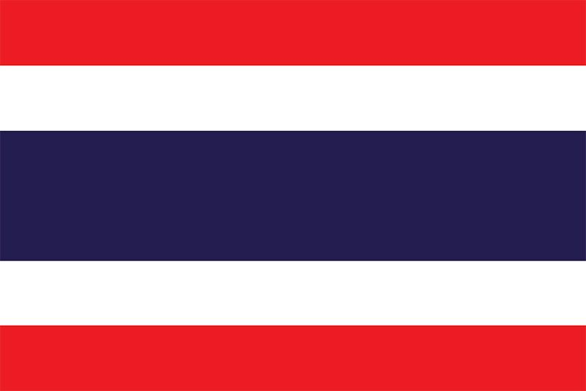
Comittee: WHO
Country: The Kingdom of Thailand
Agenda Item: Legalization of Euthanasia

Thailand is a country located in Southeastern Asia bordering the Andaman Sea and the Gulf of Thailand. Neighboring countries include Burma, Cambodia, Laos, and Malaysia. Thailand was actually known as Siam until 1939, but now is officially known as the Kingdom of Thailand; meaning land of the free. Thailand became independent in 1238. Thailand contains multiple religions, most popular being Buddhism. Approximately 94% of Thailand’s population believes in Buddhism, followed by Islam with 4%, Christianity with 1% and Hinduism with 0.03%. The word “euthanasia” itself comes from the Greek words “eu” (good) and “thanatos” (death), referring to euthanasia being the patient’s choice to die. Euthanasia is ending a patient’s life when given consent to limit the patient’s suffering.

Euthanasia is legal in Belgium, Canada, Colombia, Luxembourg, the Netherlands, New Zealand, Spain and several states of Australia; however it is illegal in many countries. Some reasons behind the rejection of euthanasia can be categorized as religious and ethical. A patient accepting euthanasia may be agaisnt his or her religion, since it counts as suicide. A non-religious view can still be against such action simply because of the common belief of suffering provides an opportunity to grow not only in empathy but also with wisdom. Another ethical view would be the idea of euthanasia decreasing the value of life and encourages vulnerable people to accept death. It is also an arguement that it may discourage the search for new cures which will lead to reduction of medical improvement. Because allowance of euthanasia affects the ambition and determination of doctors or nurses negatively, knowing that ending a life is an option to stop patient’s suffering.

Thailand offers a high standard of healthcare, and treatment can be both better and cheaper than in some Western countries. Despite not being expressingly said, Thailand only has an allowance in Section 12, known as refusing resuscitation or medical treatment that would only prolong patient’s terminal state of life. Active euthanasia, is when the doctors or nurses end a patient’s life, is however strictly not welcomed in Thailand. A patient has the right to refuse but doctors cannot speed up the death process in any way, making the end of patient’s life either natural or purely his or her choice with no encouragements. That way patient’s decision is less manipulated and if we can show people the value of suffering and encourage them to have faith before reminding the choice to die we believe the quality of medical development will greatly increase and will benefit to everyone.

