Comittee: UNWOMEN
Country: Zimbabwe
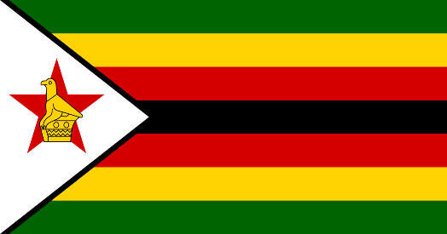
Agenda: Gender Related Mobbing

Zimbabwe, officially the Republic of Zimbabwe, is a landlocked country located in Southeast Africa, between the Zambezi and Limpopo Rivers, bordered by South Africa to the south, Botswana to the south-west, Zambia to the north, and Mozambique to the east. The capital and largest city is Harare. Zimbabwe is almost three times the size of the UK. Population is almost 15 million. Zimbabwean people uses US dolar and they speak three languages which is English, Shona and Ndebele. GDP of the country is 26,22 billion USD. Zimbabwe has the most inflation and unemployment rate in the world.

Mobbing has become rampant in all places all around the world. Even in more prosperous countries, mobbing is observed by the searches. Also in the countries with high mobbing, health sector is in the top of the mobbing list. But in some other countries, all actions that endangering the mobbing are prohibited. However employees have not special protection for mobbing. Both genders are mobbing and victims of mobbing but according to the researches, women victims are more than men. Since 1945, women have always been on the agenda in UN.

Statistics of violence against women occuring every seventy-five minutes in Zimbabwe, demand a more critical as to the underlying causes of such a national emergency. Zimbabwe adopted a constitution that provides equal representation of women and men in all positions. However, women’s participation in leadership and politics remains low at 35% in parliament, 16% in local government and 11.5% in Cabinet. Whether violence occurs within the workplace or outside, the financial effects of gender based violence on the workplace are substantial. UN Women convened an Expert Group Meeting in December 2010 to address the workplace effects of gender-based violence.

Mobbing is conduct which has been prohibited by the labour laws of many countries, including Zimbabwe. Most organisations in Zimbabwe have put together anti-harassment, intimidation and bullying policies among other important policies. By putting in place codes of conduct or anti-harassment policies, organisations are able to define sexual harassment more widely than the legislature has done in Zimbabwe. Even though, more could do about mobbing. We believe that as United Nations member, we all can prohibit mobbing.

