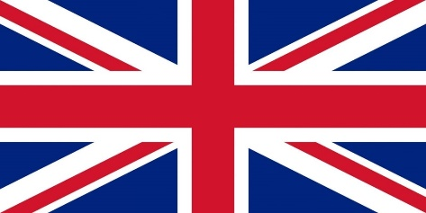
Country: United Kingdom
Committee: UNWOMEN
Topic: Gender Related Mobbing

The United Kingdom of Great Britain and Northern Ireland, commonly known as the United Kingdom (UK) or Britain, is a country in Europe, off the north-western coast of the continental mainland. It comprises England, Scotland, Wales and Northern Ireland. The United Kingdom includes the island of Great Britain, the north-eastern part of the island of Ireland, and many smaller islands within the British Isles. Northern Ireland shares a land border with the Republic of Ireland; otherwise, the United Kingdom is surrounded by the Atlantic Ocean, the North Sea, the English Channel, the Celtic Sea and the Irish Sea. The total area of the United Kingdom is 242,495 square kilometres, with an estimated 2020 population of more than 67 million people.
The United Kingdom is a constitutional monarchy and parliamentary democracy. The capital and largest city is London, a global city and financial centre with a metropolitan area population of over 14 million. Other major cities include Birmingham, Manchester, Glasgow, Liverpool and Leeds. Scotland, Wales, and Northern Ireland have their own devolved governments, each with varying powers.
United Kingdom is completely aware of the danger and fighting against harassment and mıbbing. Bullying itself is not against the law, but harassment is. This is when the unwanted behaviour is related to gender.
With reference to the EU Amsterdam Treaty and the adoption of the EU s anti-discrimination Directives, the Equality Act 2010 outlaws employment discrimination and harassment on the basis of sex, race, sexual orientation, religion and beliefs, and age. In addition the Act also outlaws discrimination on the basis of gender reassignment (protection for transsexual employees). Thus Section 26 of the Equality Act 2010 states that: 1) A person A harasses another B person if a) A engages in unwanted conduct related to a relevant protected characteristic, and b) the conduct has the purpose or effect of violating B s dignity, or creating an intimidating, hostile, degrading, humiliating or offensive environment for B. However, to assess whether the conduct has the effect indicated in the following factors need to be considered: a) the perception of B (in other words the subjective experience of the offended person)(my comment), b) the other circumstances of the case and c) whether it is reasonable for the conduct to have that effect. According to the Equality Act 2010, harassment is defined as: ...unwanted conduct related to a relevant protected characteristic, which has the purpose of or effect of violating an individual s dignity or creating an intimidating, hostile, degrading, humiliating or offensive environment for that individual. Thus, the act cannot be applied to someone who does not come from a protected group or cannot claim protected status. 67 Workplace Bullying in United Kingdom The Equality Act also covers Third-party harassment, which refers to experience of members of all protected groups, making the Employer potentially liable for harassment from third parties such as customers. In order for such liability, known as vicarious liability to come into play, the incident must have happened on at least two occasions, the employer must have been made aware of it and must have failed to take action to stop it.

Bibliography:
https://en.wikipedia.org/wiki/United_Kingdom
https://www.gov.uk/workplace-bullying-and-harassment
no.12_u.k..pdf (jil.go.jp)

