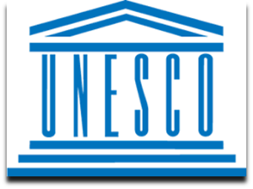
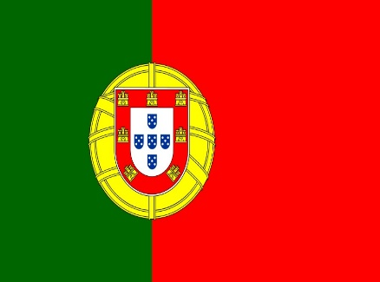
Climate Change Education,Training and Public Awareness

COMMITEE: UNESCO
COUNTRY: PORTUGAL
DELEGATE: TUNA ÖKSÜZ

Portugal, or officially the Portuguese Republic (Portuguese: República Portuguesa), is the westernmost country of the European Continent, located on the Iberian Peninsula in the southwest of Europe. Portugal is surrounded by Spain to the north and east, and the Atlantic Ocean to the south and west.

In the last two decades, climate change has become a public and political issue of great importance. Initially emerging in the scientific field, the issue received high levels of attention in the media and other public areas. Climate change, which has strong ties to the economic field, also has very important ethical and cultural dimensions.

The Portuguese Constitution only in 1976 gave priority the fundamental right to the environment, and a Law on environmental issues has only came into being in 1987, presenting and innovative vision for the concept of environment that has come to adopt. Since the protests occured after Lisbon floods, in 1967 , a historical approach to milestones of environmental policy in Portugal.
As a result of a civil society that more than thirty years won real political and social rights, the absence of a culture of a public participation, the absence of an institutional structure, solid and able to withstand partisan alternation and change of guardianship , and a legislative framework, robust enough to tackle the real problems of the country, environmental issues are recent in public policy, political agenda and in the speech of the Portuguese, and this is due to this very particular course of Portugal.

