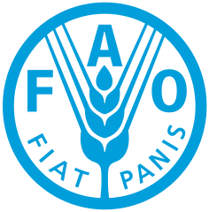

COUNTRY: CHILE
COMMITTEE: FAO
TOPIC: ENSURING SUSTAINABLE FOOD PRODUCTION AND DISTRIBUTION TO ACCOMADATE THE INCREASING WORLD POPULATION.

Chile is a country with good climatic conditions and abundant water resources that favors Chile's agriculture. The agriculture sector employs approximately one-sixth of the country's labor force and forms the second largest source of its exports. The value of these agricultural exports continues to grow. Chile is the largest fruit exporter in the southern hemisphere and the largest global exporter of blueberries, cherries, table grapes, and plums.

Agriculture is one of the main economic activities in Chile. Chile has a great variety of unique products of global value that enriches the planet's biodiversity. Our country is a globally recognized supplier due to its reliability and compliance with international food safety standards. We believe that it is very important to distribute food fairly and make sure that people have regular access to enough high-quality food and live healthy lives.

As the delegate of Chile, we would like to find solutions for this problem and hopefully defeat hunger.

