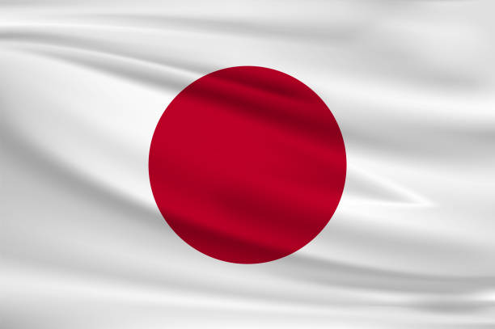

COUNTRY:JAPAN

COMMİTTEE: UNWOMAN
TOPIC B: GENDER RELATED MOBBING
Japan is a developed country, member of OECD, and a great power in global politics.japan’s economy is highly developed social market economy,often referred as an East Asian model. It is the world's second-largest developed economy.The women movement in Japan is dynamic, diverse and promising. During the post-war years, the Japanese women’s movement come to boast a great diversity in terms of both its areas of focus and membership.
With the development of society, more and more girls are going to colleges to receive higher education Today, more than half of Japanese women are college or university graduates The proportion of female researchers in Japan is 14.6%. Violence against woment is defined as any form of gender-based violence that results in or is likely to result in physical, sexual or psychological harm or suffering, including threats, coercion or arbitrary deprivation of liberty, occurring in public or in private life. Violence against women is a human rights violation that never goes away, although its frequency and appearance varies between countries. Domestic violence is the most common but most hidden form of violence against women. Regardless of whether the woman subjected to violence lives in the same household as the perpetrator; Any violence perpetrated by a former or current spouse, partner or family member is considered as "domestic/domestic violence". Therefore, as a delegate of Japan we would like to find a solution for Mobbing.

