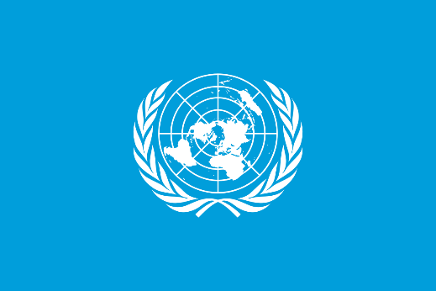
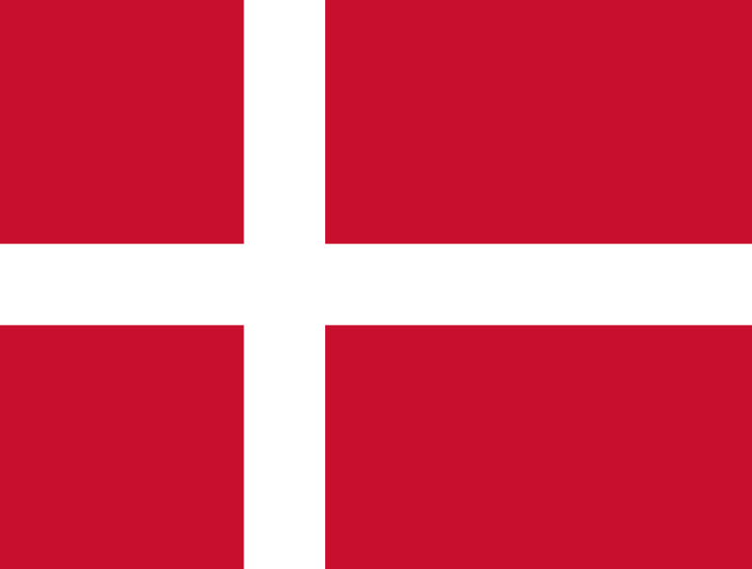
GENDER RELATED MOBBING

Country : Denmark
Committee: unwomen
Delegate: Aslı Hin
Denmark is one of the world's leading countries in women's rights and gender equality and is an example to the world with its policies.
In Denmark, women and men are equal in business life, it is normal for any woman to do the same job as a man, regardless of profession. In addition, mobbing is almost absent in business life, which plays an important role in raising the level of prosperity of the country and making the country one of the happiest countries in the world. In addition, there is no gender discrimination in salaries like some other countries, what is important is the individual's ability, compatibility and education. For example, in government, Denmark is one of the countries in the world that gave women the right to elect and be elected in 1915, giving women the right to elect the earliest in the world, and is a country that takes the lead in supporting the place of women in government. As an example, 48 percent of the deputies in the Danish parliament are women.Denmark's policy, which leads the world and is one step ahead, is that women who have been raped in Denmark do not go unanswered as a result of applying to authorized places. The only thing that is necessary for the complainant to be punished is to prove the rape by the complainant. In addition, with the strengthened law, evidence used to have to be shown, but with the new law, this will be considered rape if there is no consent on the 2nd side. However, in the neighboring country of Sweden, with this law, there was a 75 percent increase in convictions. Denmark is the 12th country in the world to adopt this law. the country has become As the delegate of Denmark, we want to find solution for the mobbing issue.

