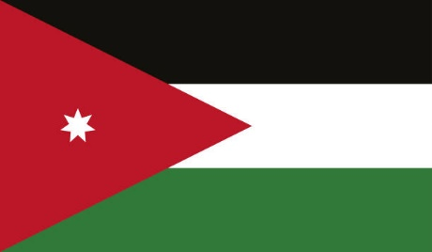
Gender Related Mobbing

Country: Jordan
Committee: UNWOMEN
Delegate: Aral Başsoy

Primarly, Traditional and cultural ideals of femininity effect how women are viewed and treated in Jordan. Throughout history, the political, social, and economic status of women in Jordan has varied based on the legal, traditional, cultural and religious values at the time. Women's rights and experiences in Jordan also vary based on other factors, such as class, place of origin, religion, and other factors. The Jordanian Constitution was written in 1952 and states that all Jordanians shall be equal before the law. There shall be no discrimination between them as regards their rights and duties on grounds of race, language or religion. Many constitutional provisions affirm basic rights and political representation for all. As a further example, Article 22 states that each Jordanian has equal opportunity to be appointed to and serve in public office, that such appointments shall be made on the basis of merit and qualifications.
Queen Rania of Jordan has used her position and power to support women's rights. In March 2008, she launched a video blog as part of her efforts to deconstruct stereotypes about Arabs and promote dialogue with the West.
With a female literacy rate of 97.4%, Jordan has the highest female literacy rate in the Middle East.
The majority of Jordanian women are both literate and highly educated; differences in career expectations based on gender tend to stem from cultural practices, not the fact that women are not as meritorious as men.
Consequently, as the delegate of the Jordan we want to find long term solutions for the mobbing problems in Jordan and all around the World.

