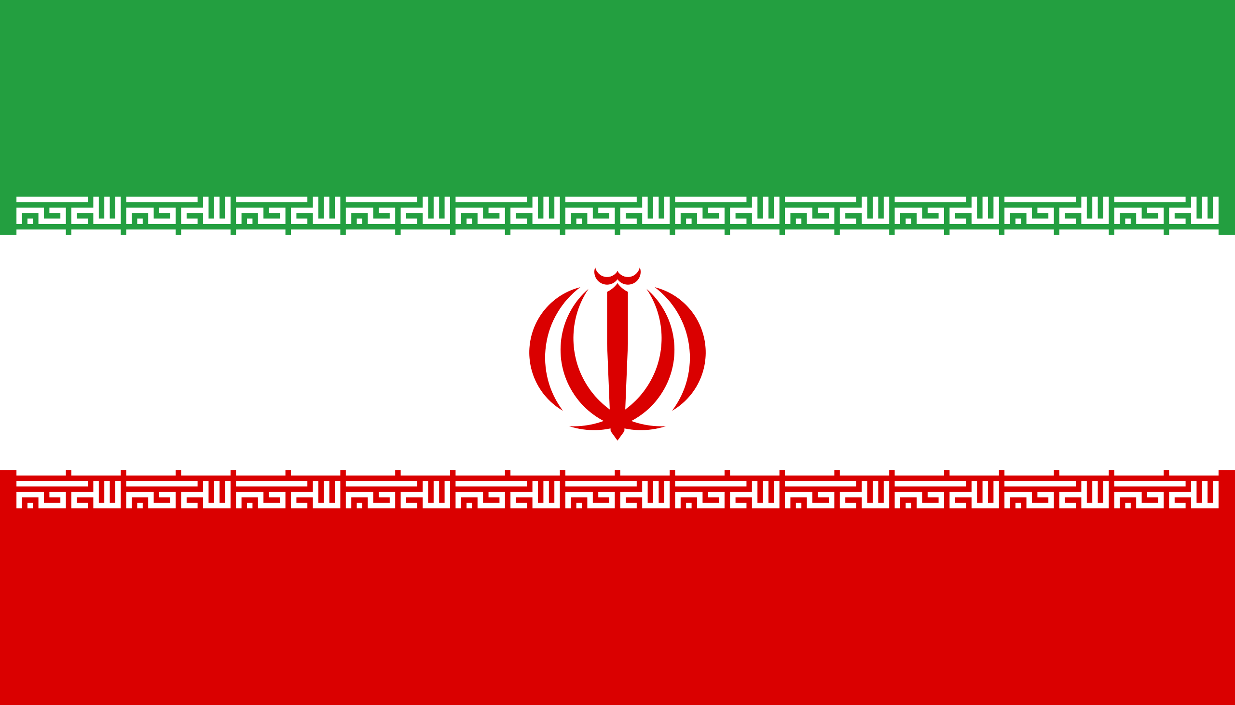Legalization of Euthanasia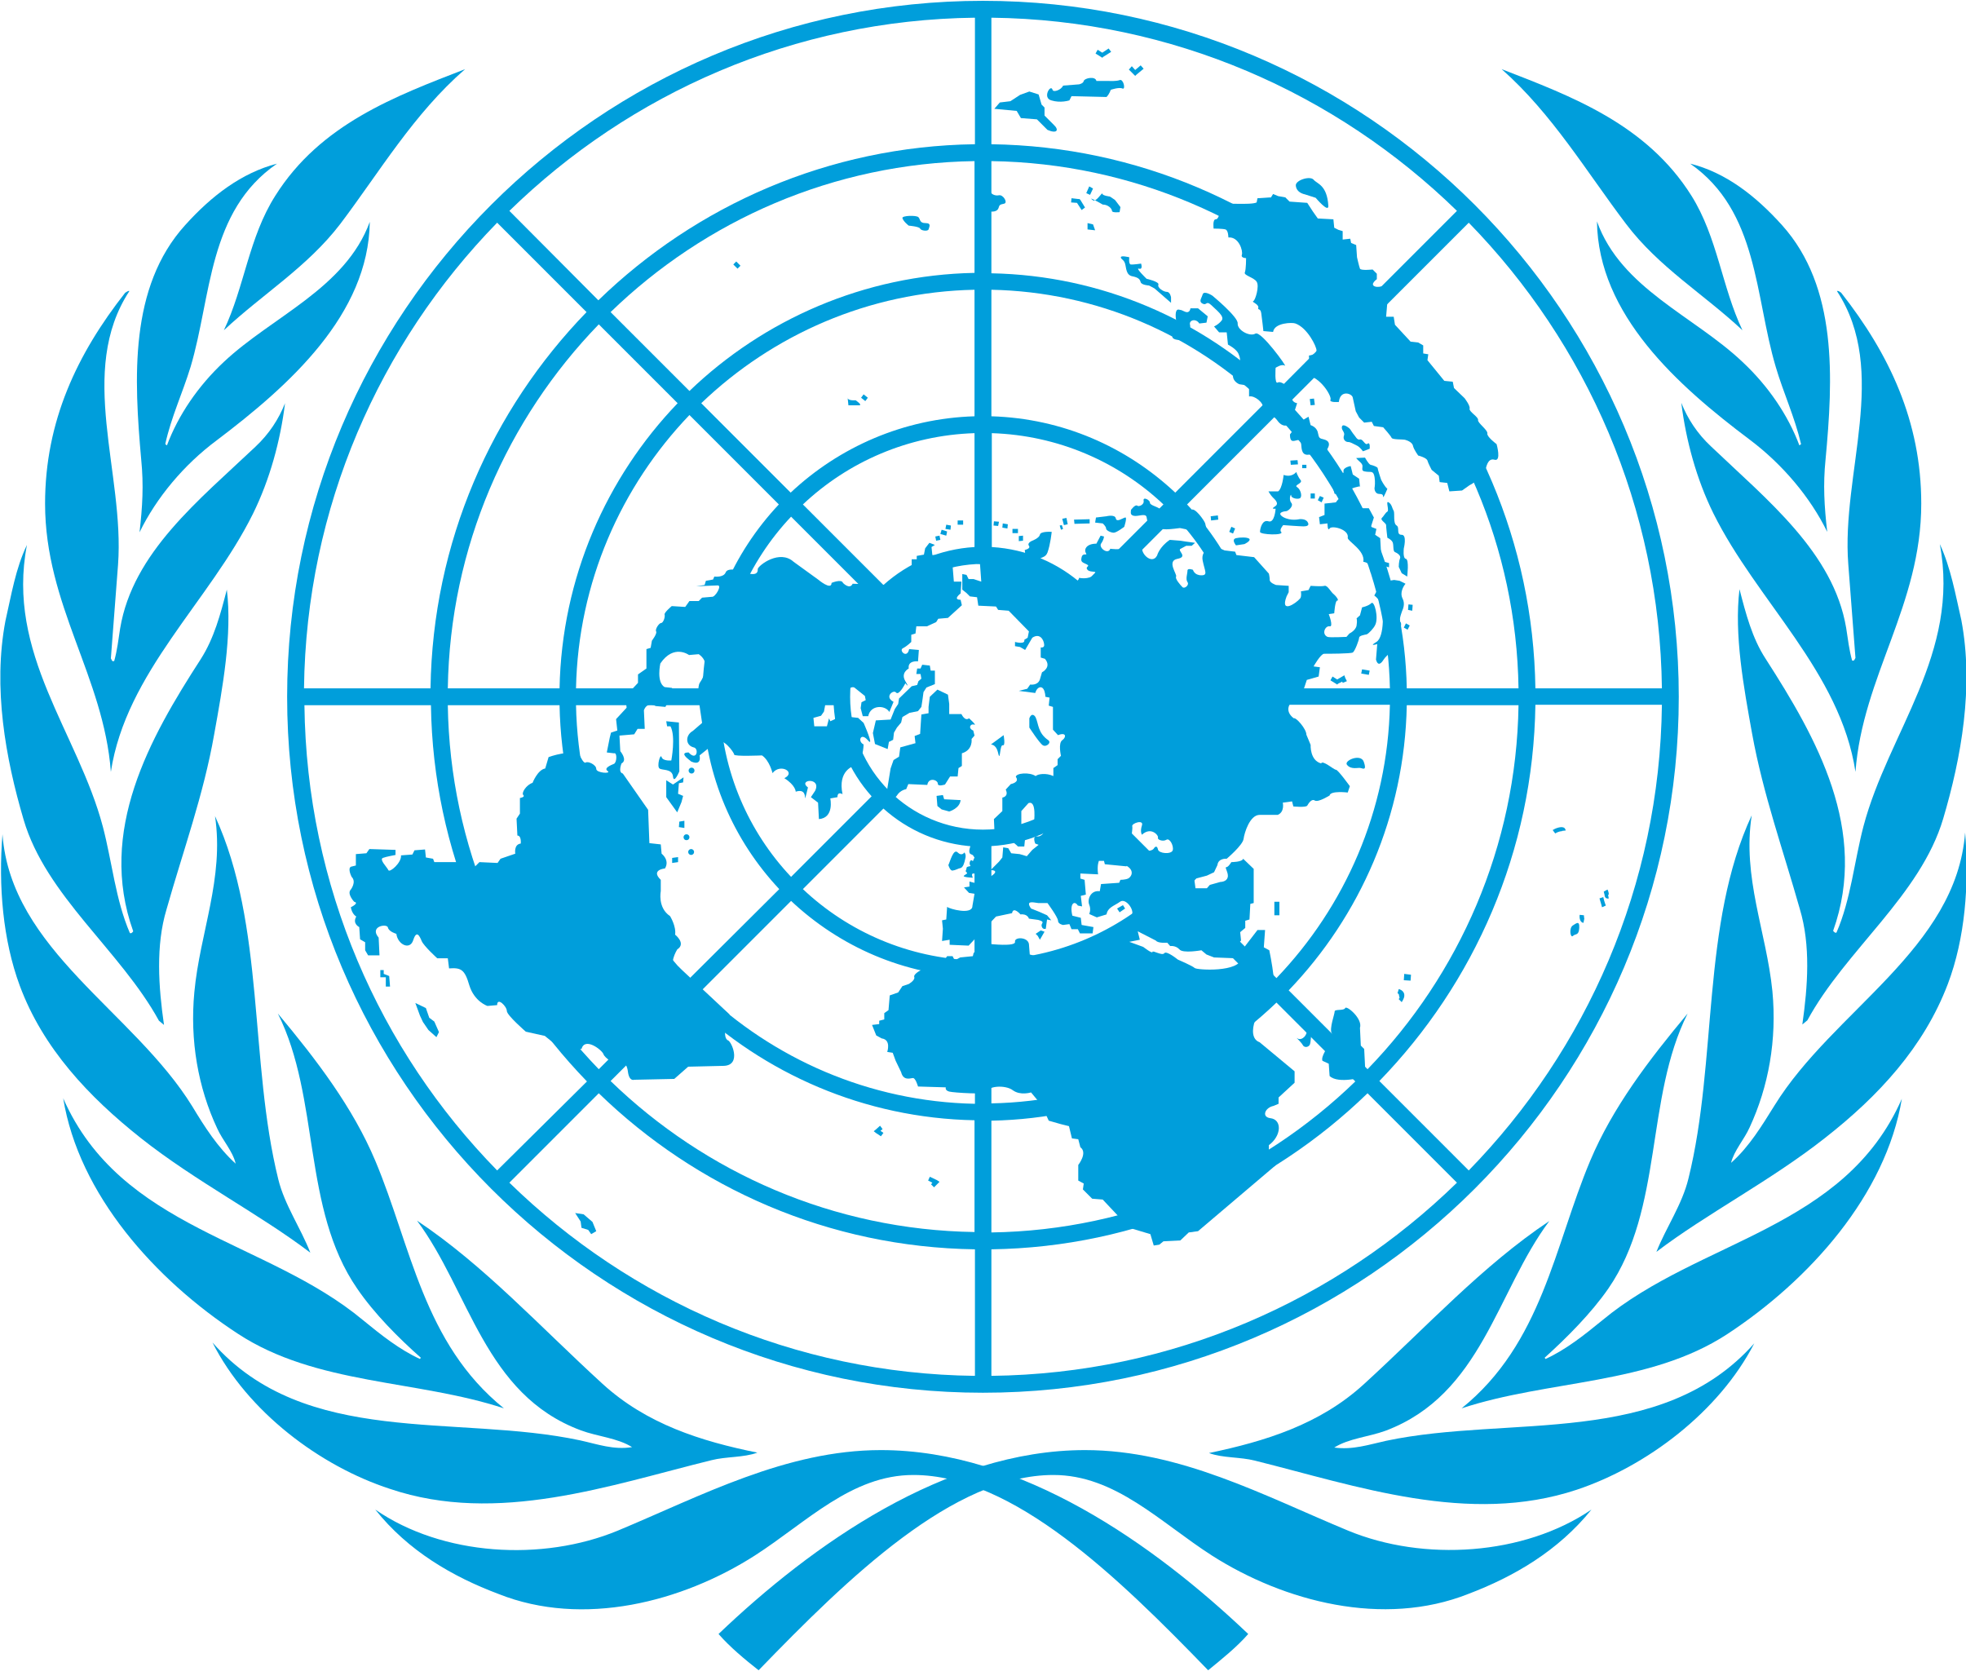
Country: The Islamic Republic of Iran
Committee: WHO (World Health Organization)
Delegate: Alp Mazman
Euthanasia is the act of deliberately ending the life of a person in order to relieve suffering. The World Health Organization (WHO) is an international organization that works to promote and protect public health. The issue of euthanasia has been a highly contested one, with debates over whether it should be legal or not. In this position paper, we will argue in support of the illegality of euthanasia in Iran, based on the WHO’s stance on the issue.
The WHO has taken a stance against the legalization of euthanasia, citing a number of ethical, legal, and practical concerns. Ethically, euthanasia is seen as a violation of the right to life, as well as a form of medical treatment that goes against the principles of beneficence and non-maleficence. Legally, euthanasia is prohibited by most national and international laws, including Iran’s. Practically, the WHO believes that legalizing euthanasia would be difficult to implement and enforce, as it would require complex systems to be put in place to ensure that euthanasia is only used in extreme cases.
In Iran, the right to life is a fundamental right that is protected by the constitution. Euthanasia is seen as a violation of this right, and is therefore prohibited by law. Additionally, the Islamic religion is strongly against the practice, and many Iranians believe that it is an immoral act. This has led to a strong public opposition to the legalization of euthanasia in Iran.
Furthermore, there are concerns about the potential for abuse if euthanasia were to be legalized in Iran. With no system in place to regulate the practice, there is a risk that it could be used as a way for people to take advantage of vulnerable patients. Additionally, the lack of regulatory measures could lead to euthanasia being used in cases where it is not appropriate, such as when patients could have been saved with proper medical intervention.
Finally, the WHO believes that legalizing euthanasia would have a negative impact on the perception of medicine in Iran. It could lead to a decrease in trust between patients and their physicians, as well as a decrease in the value placed on human life. This could ultimately lead to a decrease in the quality of medical care in the country.
In conclusion, we believe that the WHO is correct in its stance against the legalization of euthanasia in Iran. The ethical, legal, and practical concerns associated with the practice outweigh any potential benefits, and I believe that the right to life should be protected.

