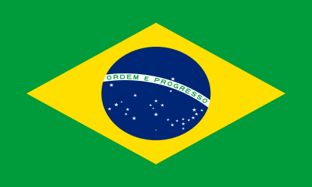 Gender Related Mobbing 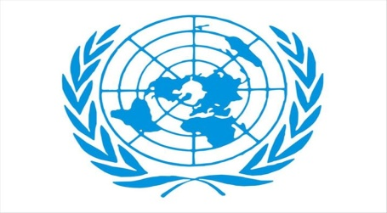

Country: Brazil
Commitee: United Nations Commission on the Entity of Gender Equality and the Empowerment of Women
Delegate: Nil Sena Koç
Primarily, in july 2010 United Nations General Assembly created UN Women. The United Nations Entity of Gender Equality and the Empowerment of Women to address such challenges. In doing so, UN Member States took an historic step in accelerating the Organization’s goals on gender equality and the empowerment of women.
Throughout history of Brazil has sought to create a democratic and egalitarian social structure due to its origins as a plantation colony and the power influence of slavery. In line with this purpose Brazil was start the many improvement works in order to protect the country’s policies and women rights.
One of the first steps taken towards this goal was taken by Bertha Lutz in 1934 with the drafting of the constitution. In 1979 Brazil adopted CEDAW’s principles of equality and, the constitution was officially revised in 1988. Following this development we have to say, Brazil is the most organized and effective women movements in Latin America.
In 2006 led by Maria Da Penha, the constitutional articles on domestic violence were amended and the Penha Lawwas adopted. In the current arrangement, all kinds of mobbing were opposed. However it is possible to say that gender has a huge and important impact on mobbing.
Consequently ın the most of the studies one third of mobbing victims are men and two thirds are women. It shows that women are the more exposed to mobbing than men. Men are generally exposed to mobbing by men and women are generally exposed to mobbing by both of them. In Brazil efforts are continious for equality and prevention of mobbing both in business life and social life.

