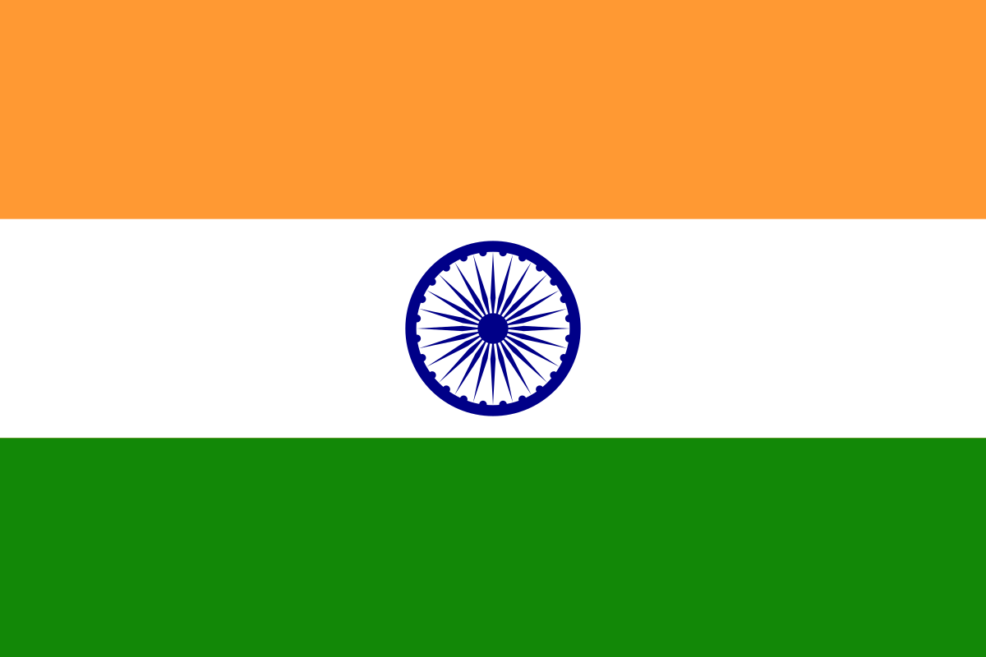
Country: India
Committee: Special Political and Decolonization (SPECPOL)
Topic: The Somalia Conflict
Delegate: Doğa Nur Ceyhan

India, as a responsible member of the international community, recognizes the significance of addressing the complex and longstanding Somalia Conflict. We believe that achieving a sustainable and peaceful resolution to this conflict is crucial for the stability, development, and well-being of the Somali people.

India firmly believes that peace and stability are essential prerequisites for the socio-economic progress of any nation. The Somalia Conflict has had devastating consequences, including loss of lives and displacement of people. India emphasizes the urgent need to establish a durable peace that addresses the root causes of the conflict and promotes conciliation with different countries.

India advocates for a political dialogue process in Somalia. We encourage all parties involved in the conflict to engage in meaningful negotiations, guided by transparency and respect for the territorial unity of Somalia. India stands ready to support and facilitate these efforts through diplomatic channels and by sharing our experiences in managing complex societies.

India recognizes the importance of building strong and effective state institutions in Somalia. We believe that capacity-building programs, particularly in the areas of governance, rule of law, and public administration, are essential for the long-term stability and development of the country. India is committed to sharing its expertise and providing technical assistance to help strengthen state institutions in Somalia.

India acknowledges the severe humanitarian consequences of the Somalia Conflict and the urgent need for humanitarian assistance. We have consistently extended our support to the Somali people through humanitarian aid, including food assistance and healthcare services. India remains committed to providing assistance and collaborating with international organizations to alleviate the suffering of the Somali people and contribute to their long-term development.

India recognizes the threat posed by terrorism in Somalia and its impact on regional and global security. We support the efforts of the Somali government, regional organizations, and international partners in counterterrorism.

India emphasizes the importance of regional cooperation and partnership in addressing the Somalia Conflict. We encourage regional organizations, such as the African Union, Intergovernmental Authority on Development (IGAD), and the United Nations, to play an active role in facilitating dialogue, peacekeeping operations, and capacity-building efforts in Somalia. India stands ready to collaborate with these organizations and other international partners to support the peace and stabilization efforts in the region.

