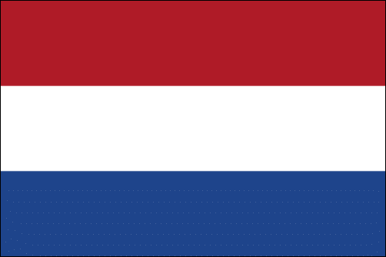
Committee: WHO
Country: Netherlands
Topic: Legalisation of Euthanasia
Legalisation of Euthanasia has always been a highly controversial topic with various policies that exist throughout the World. There are many countries where euthanasia or assisted suicide is illegal and there are also as many countries where it is legal to perform euthanasia. The reason behind euthanasia being illegal is mainly religion. The countries which give their citizens the right to choose euthanasia support policies such as right to die as well as right to live and personal liberty. So, where does the Netherlands stand on this topic?
The Netherlands exhibits the most permissive attitude in legalisation of euthanasia. Euthanasia and assisted suicide have been practiced and permitted in the Netherlands since April 10, 2001.It is a fact that the Netherlands has one the most euthanasia tolerating policies but it is a policy that is not open to any misuses of euthanasia. There are many details to go through before making a final decision. In Netherlands, the doctors must be sure that the request of the patient was fully voluntary and well considered. Euthanasia can be performed only if the patient is going through an unbearable amount of pain that leaves the patient with no other reasonable alternative. It is highly important that the patient was examined by at least one other independent physician and the whole process should be supervised by a public committee consisting of a doctor, a lawyer and an ethics expert.
As Netherlands our country supports euthanasia and thinks that it is someone’s right to choose if they want to live or to die. We believe that the choice of living is something that people can decide as individuals and also the choice of dying is up to the person (except child and coma cases which require consent of parents or close relatives.) We hope that our debate with the countries where euthanasia is illegal will be helpful to all states.

