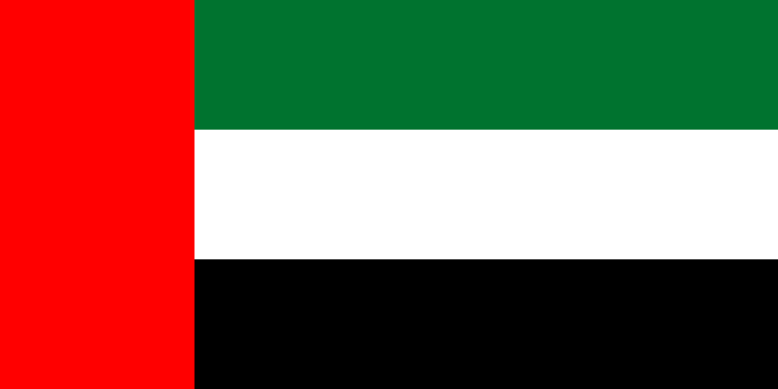Conference:Ted University traning and development conference
Committee:WHO
Topic:Legalization of euthanasia
Country:United Arab Emirates
POSITION PAPER
United Arab Emirates located in Middle East, bordering the Gulf of Oman and the Persian Gulf, between Oman and Saudi Arabia.The population is
9,991 million(2021). The constitution designates Islam as the official religion.
UAE has a comprehensive, government-funded health service and a rapidly developing private health sector that delivers a high standard of health care to the population. UAE has free public healthcare for Emirati nationals.
United Arab Emirates president says that every human is valuable and every person in this World should have an right tol ive.United Arab Emirates state attach importance to human life.And United Arab Emirates have strict laws about this issue.
United Arab Emirates think that people should die naturally not with euthanasia.Because of that euthanasia is illegal in United Arab Emirates.If doctor kills that person with euthanasia that doctor will have some strict punishment so United Arab Emirates can manage this ‘’EUTHANASIA’’ problem with this solutions. Abu Dhabi said that an outright ban is imposed on mercy killing for whatever reason and even with a dying patient’s consent or as requested by his/her guardians or relatives, a new UAE law states. Violators are facing ten years in jail, according to the legislation, which takes effect immediately.
Most of the citizens in the United Arab Emirates are Muslums.And their religion is Islam so that mercy killing(euthanasia) contravene Islam and of the reason is this. Religion is considered an important factor in determining attitudes towards such practices.
In the World most of the countrys have strict rules toward euthanasia bu there is a few which is illegal to make a euthanasia.

