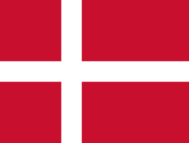

**Denmark**

**Comitee: United Nations International Children's Emergency Fund**

**Topic: Practicing Freedom of Religion with a Special Emphasis on Forciable Imposition of Religion on Young Children**

***Delegate: Muharrem Salih Özen***

Denmark is a part of the northern European region known as Scandinavia. The country’s capital is Copenhagen.Though small in territory and population, Denmark has nonetheless played a notable role in European history. During the Middle Ages, the Danish crown dominated northwestern Europe through the power of the Kalmar Union. In later centuries, shaped by geographic conditions favouring maritime industries, Denmark established trading alliances throughout northern and western Europe and beyond, particularly with Great Britain and the United States. Making an important contribution to world culture, Denmark also developed humane governmental institutions and cooperative, nonviolent approaches to problem solving.

İn Denmark the constitution guarantees the right of individuals to worship according to their beliefs. The constitution establishes the Evangelical Lutheran Church (ELC) as the national church, granting it privileges not available to other religious groups. The Ministry of Ecclesiastical Affairs is responsible for granting official status to religious groups other than the ELC through recognition by royal decree (for groups recognized prior to 1970) or through official registration. Congregations are not required to register by law, though registration is required to receive tax benefits.

Firstly, if we want to solve the problem about the freedom of religion, this comitee should focus on teaching our children to respect eachother with other religions. Secondly goverments should protect the minorties in their states, so we can have a peaceful life with other religions, And last but not least We should have some constitutions that supports freedom of religion in EVERY country.