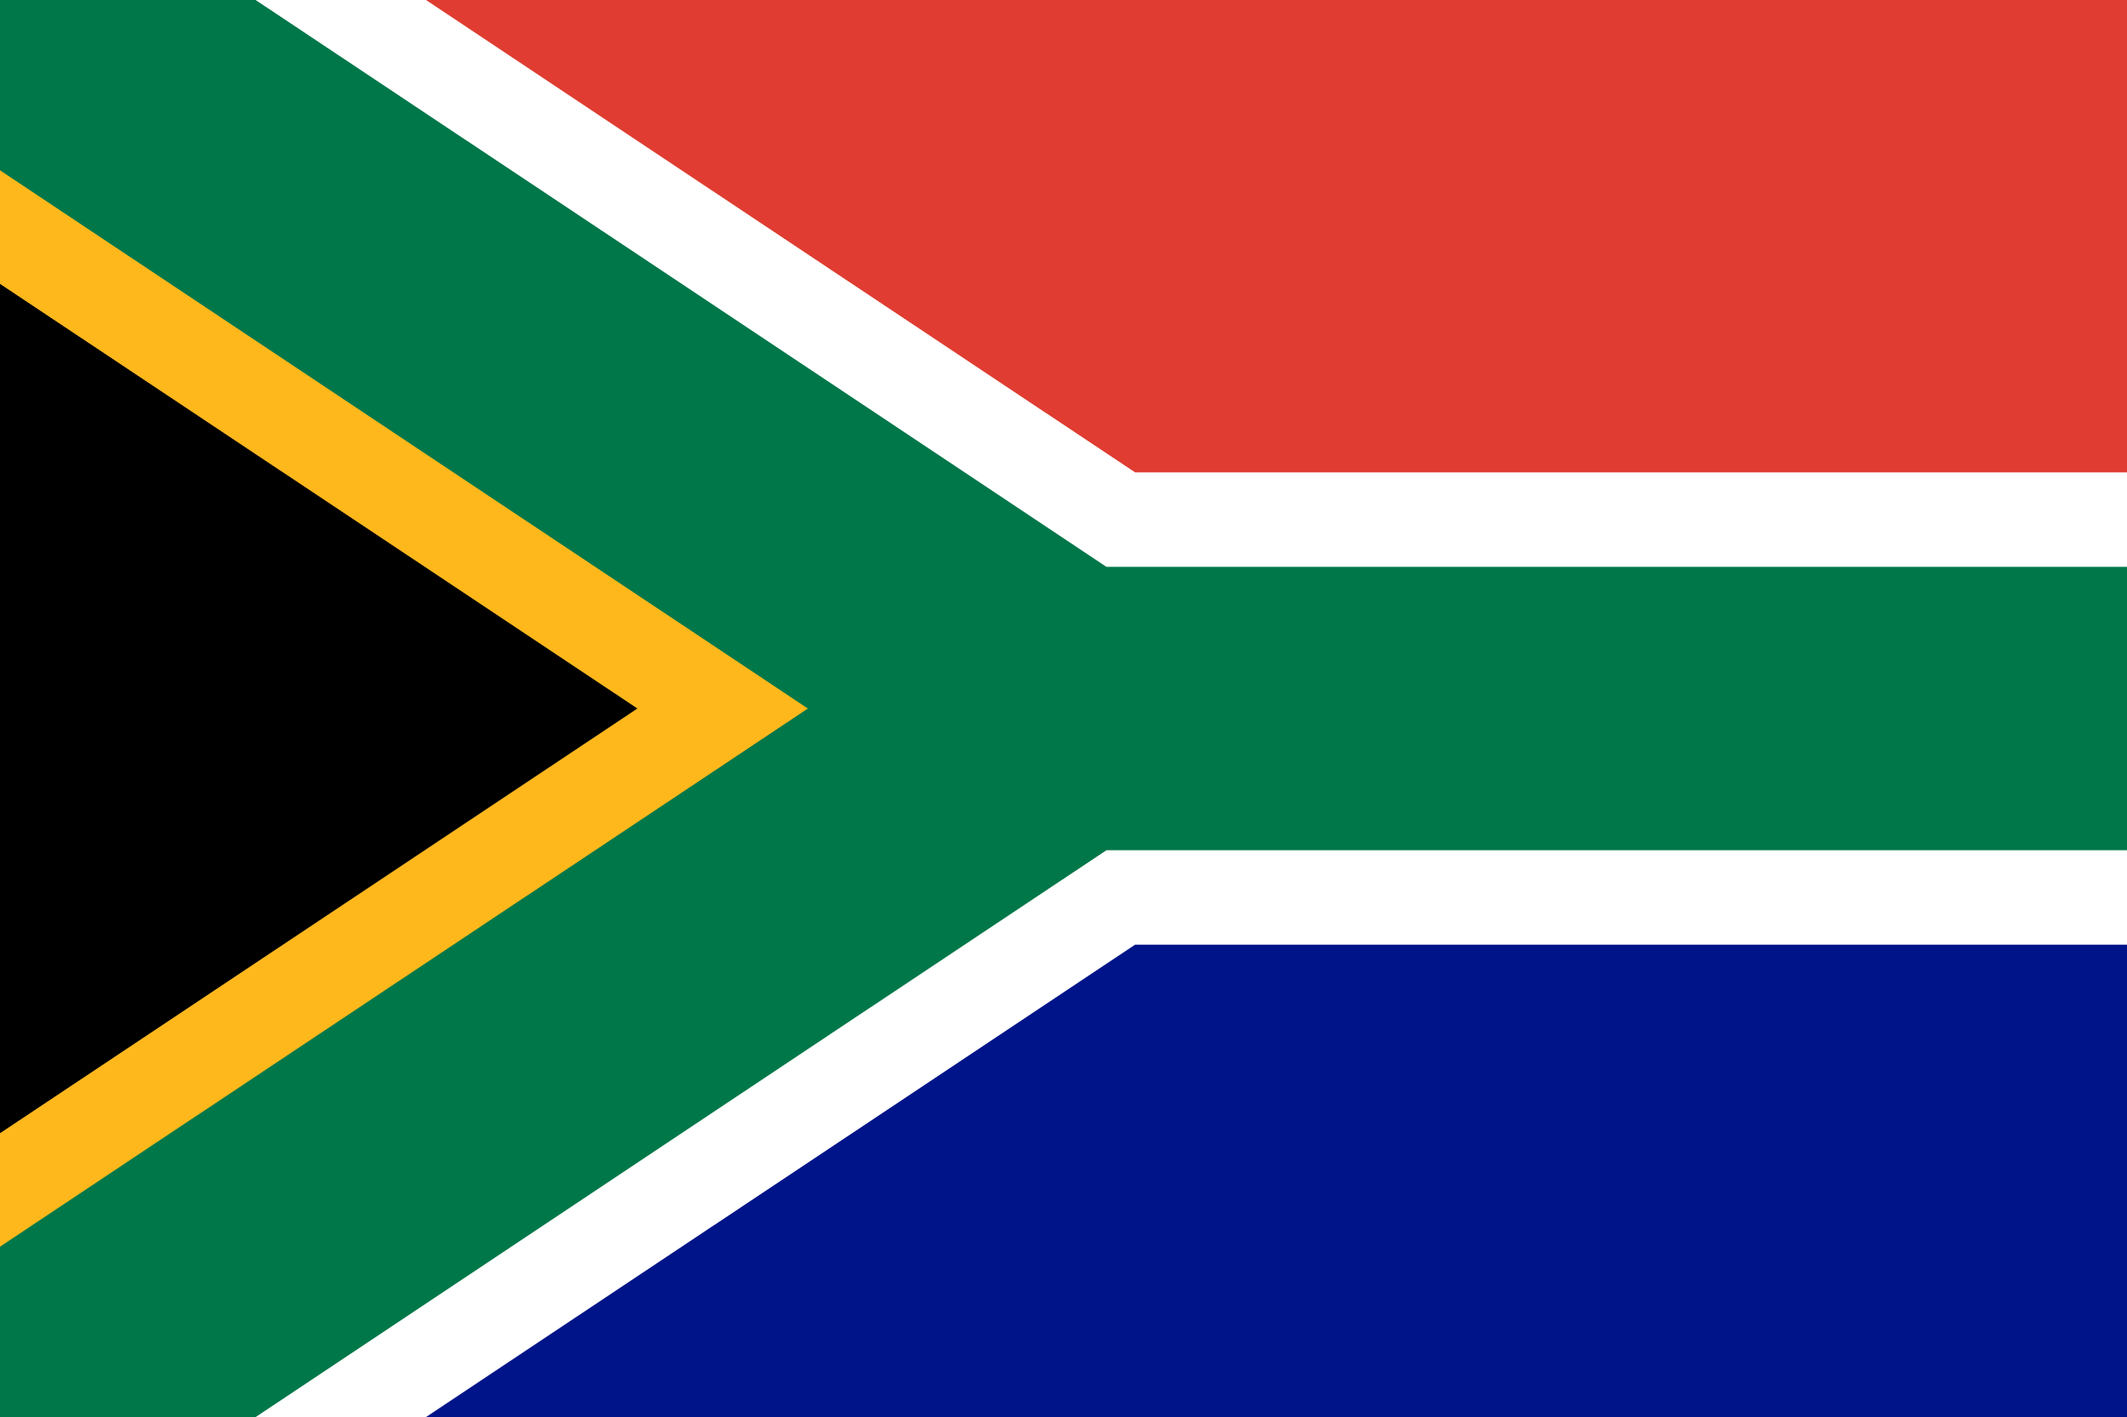 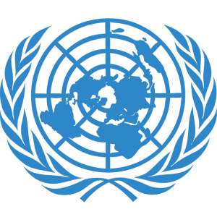

**COMMITEE:** **DISEC(Disarmament and International Security Committee)**

**COUNTRY:** **South Africa Republic**

South Africa, officially the Republic of South Africa, is the southernmost country in Africa. It is bounded to the south by 2,798 kilometres (1,739 mi) of coastline that stretches along the South Atlantic and Indian Oceans; to the north by the neighbouring countries of Namibia, Botswana, and Zimbabwe; and to the east and northeast by Mozambique and Eswatini. It also completely enclaves the country Lesotho. It is the southernmost country on the mainland of the Old World, and the second-most populous country located entirely south of the equator, after Tanzania. South Africa is a biodiversity hotspot, with unique biomes, plant and animal life. With over 62 million people, the country is the world's 23rd-most populous nation and covers an area of 1,221,037 square kilometres (471,445 square miles).

The Disarmament and International Security Committee (DISEC) is the First Committee of the United Nations General Assembly. The committee concerns itself with questions of international importance regarding the security and demilitarization throughout all countries and regions, along with ensuring that citizens across the globe remain protected. Our agenda item at this conference is a series of clashes between the Sudanese Armed Forces (SAF) and the paramilitary Rapid Support Forces (RSF). The reason for the conflict in Sudan is that Sudan is a country rich in fuel and big countries want to take Sudan under their protection. The conflict in Sudan, driven by a power struggle between the Sudanese Armed Forces and the paramilitary Rapid Support Forces (RSF), marked its 100th day on Tuesday, causing severe damage to infrastructure, healthcare, education, the economy and society.Starting on April 15 in the capital Khartoum, the conflict quickly spread to southern and western cities.It developed in the vacuum left after the ouster of former President Omar al-Bashir in April 2019 after 30 years in power.According to the Sudanese Ministry of Health, more than 3,000 people have been killed in the fighting, while casualties on both sides are estimated to be in the thousands, although no official statistics are available.UNICEF reported that at least 435 children were killed and 2,025 injured in the fighting.The UN stated that about half of Sudan's population of around 50 million people are in need of humanitarian assistance, with 14 million children in need of assistance.The International Organization for Migration (IOM) reported that more than 2.6 million people have been internally displaced by the conflict, with at least 730,000 seeking refuge in neighboring countries such as Egypt, Chad and South Sudan. The conflict has further tarnished Sudan's already troubled human rights record, leading to widespread human rights violations, including massacres, killings, torture, looting, robbery, sexual abuse and abductions of children and child soldiers.

The Sudanese people have expressed dissatisfaction with the international community's response to the crisis.Despite regional and international efforts to end the war diplomatically, a lasting ceasefire and agreement seem distant.The conflict has further tarnished Sudan's already troubled human rights record, leading to widespread human rights violations, including massacres, killings, torture, looting, robbery, sexual abuse and abduction of children and child soldiers.There has been a transition from a realistic world where power politics was implemented and wars were recurring, to a world where rules were applied, there was interdependence, solutions were sought in diplomacy, and predictable patterns of behavior developed over time. Nuclear weapons, due to their high destructive power, permanent harmful effects, and military and psychological superiority, were the weapons that states wanted to acquire in order to gain both military power and status in the early periods of the Cold War. As South Africa, we are of course on the side of the innocent and disarmament on this issue. We want there to be as few deaths and injuries as possible on this issue. We are trying to ensure that no one takes them under their protection and exploits them.

What is peacekeeping? It is the deployment of the United Nations force in the conflict area, including the consent of interested parties and soldiers, police and civilians. Thus, it was brought up as an important tool for conflict prevention and crisis management. A wide range of activities ranging from conflict prevention to permanent peace and maintenance have been included in these operations. Accordingly, a significant number of civilian personnel and police forces, as well as military units, began to participate in operations.

So how can we find a solution to this problem? Ensuring peace and security in the international arena and preventing armed conflicts disarmament control, especially in the modern era, in order totechnologies are becoming more and more advanced and a possible armed conflict the international community as it threatens the future of humanity.has become an increasingly important issue in terms of .In our view, we are not safe until nuclear weapons are completely eliminated. We need multilateralism to guide us towards our common goal of a world free of nuclear weapons. We believe that nuclear weapons should not be used. They are very harmful both for countries and for the people within countries. attributes importance to arms control, disarmament and non-proliferation efforts and arrangements because of their stabilizing features. The proliferation of Weapons of Mass Destruction (WMD) and their acquisition by terrorists has become a serious threat to not only regional but also global peace and security. Turkey believes that the international community, in cooperation, should strive for a more secure and stable world in line with the goals of disarmament and non-proliferation. We will be open to all proposals and express our opinions throughout this conference.

<https://tr.wikipedia.org/wiki>

<https://www.aa.com.tr/tr>

<https://munuc.org/committees/disec-34/>

<https://dspace.yasar.edu.tr/bitstream/handle/20.500.12742/18750/707639.pdf?sequence=1&isAllowed=y>