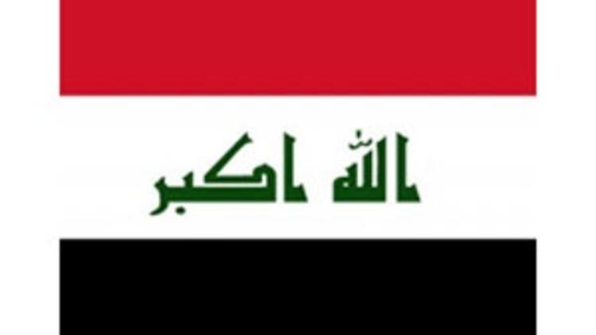
Committee: UN WOMEN
Topic: Women's Access to Justice and Legal Protection
Country: Iraq
Delegate: Müzeyyen Firdevs Sümer

The Republic of Iraq is in the middle east. Its capital and largest city are Baghdad. There are various ethnic groups in Iraq other than Arabs. 99% of its 38 million citizens are Muslim. Iraq is one of the substantial gulf countries in terms of its petroleum reserves and strategic position. It has the second-largest oil reserves after Saudi Arabia and the United Arab Emirates. After the war and invasions with America, there has been a significant decrease in production, but it still maintains its place during the natural reserve.
During the 1970s, which can be regarded as a development dignity in Iraq, the social services provided to the people of Iraq have improved in terms of quality. They have been given free education at all levels and started literacy campaigns by making the first level compulsory. In the same period, they made great progress in the field of health, with the opening of many hospitals and by expanding health insurance so that all Iraqis can benefit. The period of stagnation and decline has begun in Iraq, which has entered the war with Iran and allocated its entire budget to the war. The humanitarian situation in the country has deteriorated to a great extent with the quality of the service offered to the citizens after the 1991 Gulf War. In the ensuing years of the 1990-2003 embargo, the quality of service in Iraq turned into a bad situation. Before the war and invasions, the annual average income was 90 billion dollars, while this figure decreased to 25 billion dollars after the embargo. While the poverty rate before the embargo did not exceed 10%, it increased to 60% after the embargo. Before the embargo, while education was 90%, this figure decreased to 10% after the embargo

Unfortunately for women to reach justice and legal protection, it is still very difficult for women of some countries, and unfortunately, Iraq is one of these countries. While there is a 2011 law on domestic violence in the Kurdistan region of Iraq, there are fewer laws in Baghdad contours to protect women from family violence. Efforts to pass a bill against domestic violence in parliament stalled throughout 2019. The criminal law in Iraq, which is valid both in Baghdad-controlled lands and in the Iraqi Kurdistan Region, makes physical assault a crime, but there is no clear statement of domestic violence.
Human Rights Watch and other organizations documented the organized rape, sexual slavery, and forced marriage system of Yazidi women and girls by ISIS forces between 2014 and 2017. However, no ISIS member in Iraq has been tried or convicted of these specific crimes.
Violence against women in the domestic sphere is an issue that precedes the conflict but at the same time, it is integrally and undeniably connected to the conflict .since the first gulf war, ıraq has seen an increase in certain types of violence that are otherwise on the decline in neighboring countries of the region . with the economic crisis brought on by that war and ensuing sanctions, many families began forcing their underage daughters to the marriage.

In Iraq, non-governmental organizations are the most helpful for women to reach justice, but in Iraq, non-governmental organizations are not provided with sufficient funds. The biggest reason why women in Iraq cannot reach justice is the wars and civil conflicts they have made, and isis, which has been there for a long time, has made this situation even more difficult. Internal turmoil increases in Iraq, where the distinction between Shiite and artificial is high

