Gender Related Mobbig 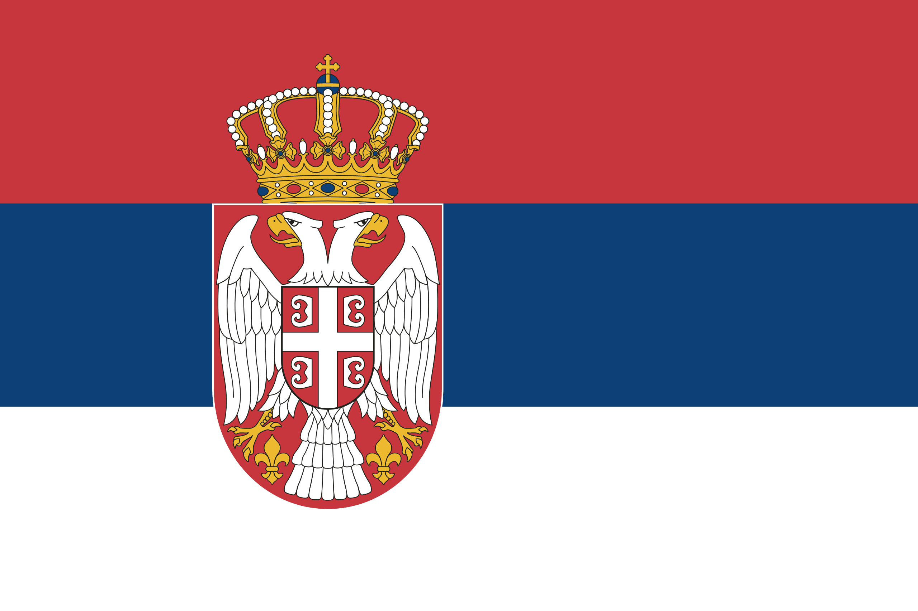 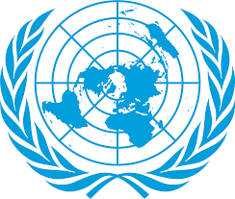Country : Serbia
Committee: UN-WOMEN (United Nations Entity for Gender Equality and the Empowerment of Women)
Delegate: Fatma Beren Sansar

Serbia is located in the Balkans. Its population is 6.9 million according to the 2020 census, and a large part of its population is Serbs.
The respect that society has for the rights of women in Serbia varies from person to person. Some people in the society think that women should not have the same rights as men due to reasons such as custom. and this complicates their lives for women to start working life. But we are working on this issue, we give them some advantages to encourage women to work, we provide training on issues that women are victims of, such as gender-based violence, we did the Orange the World - 16 Days of Activism campaign in partnership with the Serbian government, and as a result of all this, the lower part of the society We have witnessed that he is becoming more conscious day by day.

