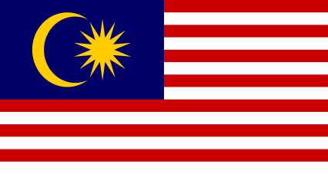
COMMITTEE: UNWOMAN
COUNTRY:MALAYSIA

Malaysia is a state in the southeast Asian continent , consisting of 13 states , divided into two land parts as east and west , governed by a monarchy-based parliamentary democracy . Its population is 32.7 million and the country's surface area is 329.847 km ² . In addition to its mother tongue being Malay and its official religion is Islam , it is a multicultural country . At the same time, Malaysia is a member of many international organizations such as the United Nations (UN), the World Trade Organization (WTO), the International Development Association (IDA), the Permanent Court of Arbitration, and UNESCO. Malaysia, which has the 3rd largest economy in the Southeast Asian region, reached full employment level in 1995, which was an important point in the progress of the country's economy, and women's labor force participation has increased tremendously since 1970. Women make up 43.4% of the workforce in the manufacturing sector , yet educated women are less likely than men to be hired, even though they make up a large part of the lower ranks of government jobs .
Moreover, despite the gains made by Malaysian women in education, health and labor force participation, there are still issues regarding working conditions that need to be addressed. These relate to women's political participation, the need to diversify and improve employment opportunities and working conditions for women workers. Although the inequalities in the workplaces are reflected superficially , there are concerns about the discriminatory situations applied to women in particular. 66% of mobbing applied to women can be in many physical and mental aspects and is divided into types such as violence, oppression and intimidation policy. It can cause serious physical and psychological problems such as depression, anxiety , anxiety in the people who are applied . In workplaces and organizations where mobbing is applied, it is seen that the performance and efficiency of the employees decrease, their motivation decreases, the probability of making mistakes increases and their commitment to work decreases.
The Malaysian Government reaffirmed its commitment to improving the status of women at the United Nations Fourth World Conference on Women held in Beijing in September 1995. The Beijing Declaration and Platform for Action was unanimously adopted by all participating members of the United Nations . Malaysia to involve more women in decision-making; protect the rights to health, education, employment and social welfare; takes steps to eliminate legal barriers and discriminatory practices. The Government and its NGOs work in collaboration with universities and the private sector to improve the status of Malaysian women. The National Advisory Council for the Integration of Women in Development was established in 1976 as a coordinating and advisory body on women's issues. The Human Development Report (HDR), 1995, placed Malaysia at 59 on the human development index and 38 on the gender-related development index (GDI). This indicates that it outperforms only the average achiever in gender equality.

All over the world today mobbing can occur. States should enact deterrent laws to minimize the pressure on businesses and organizations . In addition, mobbing training should be given to the employees and they should be taught how to act in case of such a situation. It should be emphasized that people should follow the administrative-legal processes and seek the rights of the oppressed individual. Necessary support should be given by state institutions and NGOs in this process . Social cooperation and sensitivity are of great importance in preventing mobbing .

https://www.adb.org/sites/default/files/institutional-document/32552/women-malaysia.pdf
https://www.mfa.gov.tr/malezya-kunyesi.tr.mfa
https://en.wikipedia.org/wiki/Malaysia
https://en.wikipedia.org/wiki/Women_in_Malaysia
https://www.munpoint.com/tr/dokuman-merkezi

