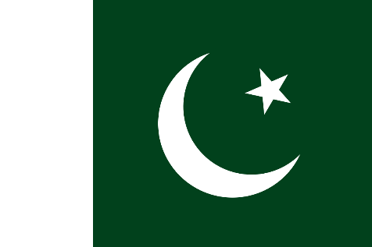
Committe :Food and Agriculture Organisation
Agenda item :Ensuring sustainable food production and distribution and accommodate the increasing World population
Country:Pakıstan
The total population of Pakistan is 212 million. With this population, it is the 5th most populous country in the world. The area of Pakistan is 881,913 km2. With this surface area, it ranks 33rd in the world. Its capital is Islamabad and its largest city is Karachi. Its official language is Urdu and English. Its official religion is Islam. Pakistan has a 1046 km coast on the Arabian Sea and the Gulf in the south. It borders with India in the east, Afghanistan in the west, Iran in the southwest and China in the northeast.

It has been determined that the flood disaster in Pakistan will increase food insecurity and 5.7 million people living in the flood-affected areas will face the risk of food crisis in October and November.It was emphasized that waterborne diseases increased in Sindh and Balochistan provinces, and it was stated that 130,000 pregnant women living in temporary camps needed emergency health care.Numerous countries and UN agencies have sent more than 131 aid planes to Pakistan. However, flood victims report that they received little or no help and are still waiting for help.

We should evaluate the aid received for this problem well, and give each person what he can get enough of, not more. We should use our budget carefully for this problem. We should give food and agricultural support to the farmers. We should not allow the least waste, unnecessary spending. We should get help from the people. In such a difficult situation, we should We must be in solidarity.

