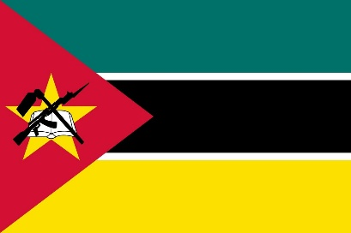
Delegate: Mozambique
Committee: Food and Agriculture Organization
Agenda Item: Ensuring sustainable food production and distribution to accommodatethe increasing world population

Located in Southeast Africa, Mozambique is a low-income, food-deficient country with a largely rural population of 28 million. It was ranked 181 out of 189 countries in the 2020 Human Development Index, 103 out of 107 countries in the 2020 Global Hunger Index, and 127th out of 162 countries in the 2019 Gender Inequality Index. Independence in 1975 was followed by a 16-year civil war that ended in 1992. Twenty years of peace and stability have enabled Mozambique to make progress socially and economically. The Peace and Reconciliation agreement was signed in July 2019, and the government and international forces jointly initiated the process of demilitarization, demobilization and reintegration.
Escalating violence in the northern Cabo Delgado province is causing mass displacement. As of March 2021, 697,000 people had been driven away from their homes. Some 80,000 people are in areas made inaccessible by insecurity. The ongoing conflict is a driver of hunger. More than 950,000 people in the provinces of Cabo Delgado, Niassa and Nampula are facing severe hunger (IPC January 2021). Cabo Delgado province has the highest rates of chronic malnutrition in Mozambique – with more than half the children malnourished – and now thousands are falling deeper into food insecurity.
Food assistance, including emergency feeding and cash vouchers.Diagnosis and treatment of maternal and child malnutrition.Access to clean water and improved sanitation to prevent water-related diseases and support crop irrigation.

