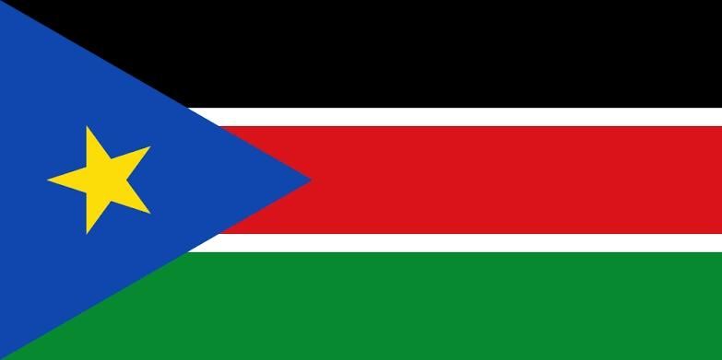
Committee: WHO
Country: Republic of South Sudan
Agenda Items: Legalization of Euthanasia

South Sudan, officially the Republic of South Sudan, is a landlocked country in East Africa. It is surrounded by Ethiopia, Sudan, Central African Republic, Democratic Republic of the Congo, Uganda and Kenya. Its population was estimated as 12,778,250 in 2019. Juba is the capital and largest city. South Sudan was settled by many of it’s current ethnic groups during the 15th–19th centuries. South Sudan seceded from the Republic of Sudan in 2011. Geographically, South Sudan is not part of the Sudan region at all, forming as it does part of Sub-Saharan Africa.
Dignity can be said as being the paramount right present when each and all human rights are fulfilled. Euthanasia goes back to Ancient Greece and Rome where it has been practicing and supported by famous such as Socrates, Plato and Seneca. Euthanasia is the practice of intentionally ending life to reduce pain and suffering but killing is never admissible. Different countries have different ideas of euthanasia. The legality of euthanasia varies depending on the country. Efforts to change government policies on euthanasia of humans in the 20th and 21st centuries have met limited success in Western countries. Because of economic crisis most of people commit suicide by euthanasia but this shouldn’t be the solution. Euthanasia not only takes the person’s dreams to an end it also it doesn’t change anything. As a region of the Republic of Sudan, South Sudan gained autonomy in 2005 the legislative competencies of the National Government of South Sudan are vested in the National Legislature in respect of all matters assigned to.
Development assistance remains a significant source of revenue for South Sudan, especially following the eruption of political conflicts in December 2013 and July 2016 that disrupted oil production. Over 6 million people can access health care this might not seem to much but our country is improving. The Ministry of Health in South Sudan developed the National Health Policy (NHP) 2016-2026, to provide the overall vision and strategic direction for development in the health sector.

