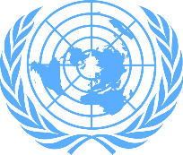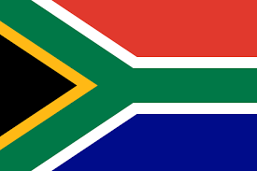

Comitee: World Health Organization
Country: South Africa Republic
Agenda Item: Legalization Of Euthanasia

South Africa is a country located in the south of the African continent. The country's border neighbors are Namibia, Botswana, Zimbabwe, Mozambique and Eswatini, with the Indian Ocean to the southeast and the Atlantic Ocean to the south and southwest. And In the Republic of South Africa, which is dominated by desert, temperate oceanic and Mediterranean climate, the climate is milder than in other parts of Africa. Average temperatures are remarkably uniform in the north and south. The west coast is under the influence of the Benguela cold water current and the east coast is under the influence of the Mozambique warm water current.
The Department of Health is the main institution responsible for health services in South Africa. Health services are organized at national, provincial and municipal levels and are provided jointly. Apart from these units, various research organizations and professional councils are also involved in the administrative structure of health services. The most important feature of the health system is the poor distribution of resources caused by the social structure disorders and imbalances arising from the racial discrimination experienced in the country until the last 15 years. While health services are at high levels in the predominantly white regions of the country, health services are at very low levels in some of the regions where more than 90% of the other races live. The gaps between ethnic groups created by earlier racist policies still exist. Intensive efforts are being made to ensure that health resources are equally available to all regions of the country. Euthanasia is the termination of a person's or animal's life by painless or minimally painful lethal injection, high doses of medication, or by removing the person from life support because their life is perceived to be intolerable.If the patient is suffering from an incurable disease, he or she can be killed by euthanasia, and religion allows this. Debates on euthanasia (or ‘mercy killing’) have been a concern in moral, philosophical, legal, theological, cultural and sociological discourse for centuries. The topic of euthanasia inspires a variety of strong views of which the ‘slippery slope’ argument is one. The latter warns that the principle(s) underlying any ethical issue may be distorted. Scholars’ views on euthanasia are inﬂuenced mainly by cultural, personal, political and religious convictions in South Africa.
Passive euthanasia can be applied in cases where the patient will suffer unbearable pain. This must be agreed upon by the patient's relatives and the patient himself). But active euthanasi unacceptable. Instead, palliative care should be developed. We believe that by relying on the superior powers of the United Nations, solutions to all problems will be found.

