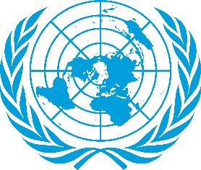
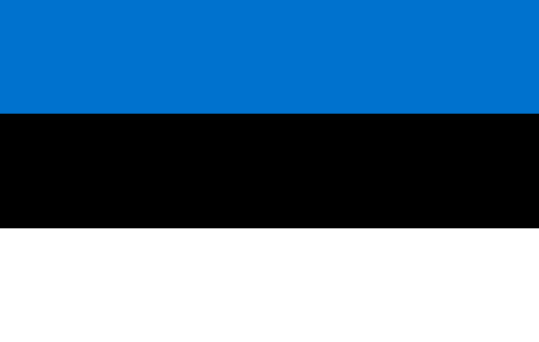

Country:Republic of Estonia
Committee:WHO
Agenda Item(s):Legalization of Euthanasia

The Republic of Estonia is a Baltic state located in Northern Europe. It borders the Gulf of Finland and Finland in the north, Latvia in the south, the Baltic Sea and Sweden in the west, Lake Peipus and Russia in the east. Its capital and largest city is Tallinn. Estonians, who are Finnish people, make up the majority of the country's population. According to studies, Estonia, Europe; It is the second cleanest country after its neighbor Finland,[6] the ninth country with the highest quality of life,[7] the fifth safest[8].
Estonia's healthcare system provides nearly universal population coverage. The health insurance system, managed by the Estonian Health Insurance Fund, covers about 94% of the population. The Ministry of Social Affairs oversees the Estonian health system. Agencies under the Ministry of Social Affairs support national health activities such as professional certifications, pharmaceutical quality assurance and public health. Hospitals in Estonia are mostly owned by the state, local or public legal bodies, while primary care centers, pharmacies and outpatient clinics (if not part of a hospital) are privately owned. Local have a minor and rather voluntary role in organizing and financing health services.
Euthanasia is the deliberate practice of ending life to remove pain and suffering. Euthanasia is categorized in different ways as voluntary, involuntary, or involuntary.[6]Voluntary euthanasia is when a person wishes to end their life and is legal in a growing number of countries. Involuntary euthanasia occurs when a patient's consent is not available and is legal in certain limited circumstances in both active and passive forms in some countries. Involuntary euthanasia without the patient's consent or against the patient's will is illegal in all countries and is generally considered murder. Religious beliefs have a great impact on this issue. The viewpoint of some religions on euthanasia is as follows: According to Islam, man was created by God and life was given to him by God. For this reason, man does not have the right to decide on his own life, this right belongs only to Allah. From this point of view, both suicide and euthanasia-like practices are prohibited in Islam and are seen as murderers. From the birth of Christianity, it was strictly forbidden to take one's own life or to take the lives of others. The belief that man was created in the image of God is also present in Christianity, and man and human life contain a special 'sacredness'. In Christianity, it is not legitimate to kill a certain social group, such as communities that have lost their social usefulness. In Judaism, the life bestowed by God will again be taken by God from a person whenever God wills, so it is not legitimate to take one's own life or someone else's life.
Different countries have different euthanasia creation.
Post-passive is legal in the Republic of Estonia. However, active or direct euthanasia is not legal. One of the reasons for this is religious beliefs. 75.7% of the people do not have any religious belief.
The Estonian constitution guarantees the sanctuary of religion, the separation of church and state administration, and the privacy of personal belief. For these reasons, medical ethics is more important for euthanasia. Execution of an individual due to his mental state should not be approved. In our opinion, a social care system full of deficiencies should not lead people to death. In such a situation, it means that the state has not been able to provide a good service to its owners. Neural support can be applied in a component that requests active euthanasia. counseling should be developed. He believes that all rules will be resolved in this very important conference of the United Nations.

