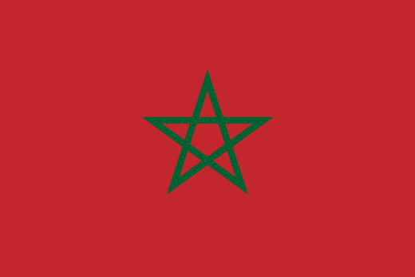
Position Paper
Committee: The United Nations for Gender Equality and the Empowerment of Women
Country: Morocco
Agenda Item: Mobbing and Mobbing Against Women

In Morocco, the current population is 37,970,315. The percentage of the women population is 50.35% compared to 49.65% men but only 26% of women working even though 97.57% is the literacy rate of women in Morocco.
Morocco is trying to convince people to have education and have ability to work. In that case, We are trying to stop bullying at schools. So we signed a new declaration to address school bullying and cyberbullying named “Campeche Declaration for the prevention of violence and bullying at school.” The declaration aims to eradicate bullying from educational institutions by 2027 and before all of this declarations we have signed Mudawana in 2004.
Mudawana concerns issues related to the family, including the regulation of marriage, polygamy, divorce, inheritage, and child custody. Therefore, included raising the minimum legal age to marriage to 18 for men and women, establishing joint responsibility for the family among men and women, limiting the terms of polygamy and divorce, and granting women more rights in the negotiation of marriage contracts, among other provisions.
We are trying to make schools and work places more peacefull places. If we can convice moroccon women to work then It will affect our economy really well.

