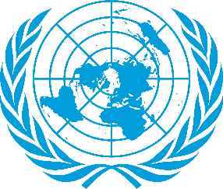

Gender Related Mobbing

Comittee: UN WOMEN
Country: Canada
Canada is a country located in North America.Canada's capital is Ottawa. Canada is covering over 9.98 million spuare kilometres (3.85 million square miles) , making it the worlds second largest country by total area. Canada's offical language is French and English.
Over the years Canada has always had different forms of aspects about “mobbing”. Mobbing is a major issue that needs to be taken care of. And becaus of that “mobbing” is always a hot topic among Canadian Goverment. Mobbing physical and psychological harrasment by an individual or a group of people. What makes it so critical is the consequences of it. The consequences can be both psychological and physical. Both men and women are affected by mobbing. However women are exposed to “mobbing” more than men. Due to fact that one third of mobbing victims are men and two third are women. Mobbing is everywhere however mobbing is seen more frequently in workshops than in other places. Due to fact of that we follow the Canada Labor Code. The code defines the rights and responsibilities of workers and employers in federally regulated workplaces and sets out federal labour law. Protecting the rights and well-being of both workers and employers no matter the gender.
The Goverment of Canada is commited to creating a diverse and inclusive public service that is free of harrasment and violonce where all citizens are treated with dignity, respect and fairness. As Canada wants permanent and suitable solutions for “mobbing”. It is thought that country’s opposion to mobbing should be clear not only verbally but also supported by policies. Therefore, we think that other countries should take action against policies as well. Reducing the workforce,people having sufficient information about mobbing, an important education and the most importantly being aware of being human in the society. Because a human being should be aware that they should never do such things like mobbing. As Canada, we are taking big steps on mobbing and women’s rights and we invite other countries to take big steps.

