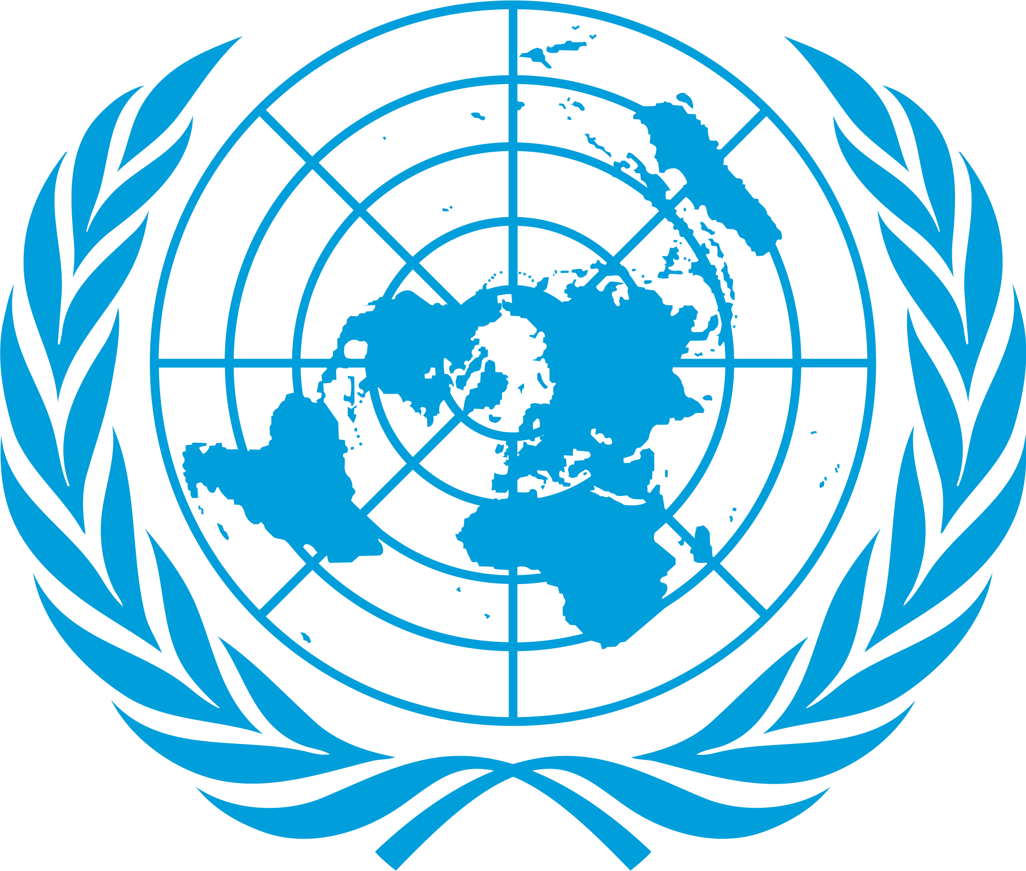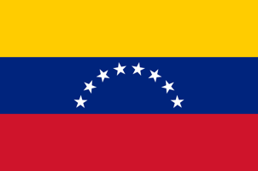
POSITION PAPER

Comittee: World Health Organization
Agenda Item:Legalization of Euthanasia

Venezuela is located in northern South America, on the coast of the Caribbean Sea and the North Atlantic Ocean, between Colombia and Guyana. It has a tropical climate. In the northwest are the Andes and the Maracaibo plains, in the center are the plains, and in the southeast is the highlands of Guyana. Looking back to 2021, the population is 28.7 million people. From 1960 to 2010, the number increased considerably, after which it dropped dramatically. Although health care is universal and free, according to a needs assessment conducted by the IRC in 2021, at least 38% of Venezuelan families considered they faced barriers to access services, mostly related to xenophobia and economic challenges. Venezuelans gives so much value on the traditions of the past.
Euthanasia means ending your life under the supervision of doctors or nurses. Euthanasia goes back to the Ancient Greece and Rome where it has been practicing and supported by famous names such as Socrates, Plato and Seneca. A life given by God can only be taken by God. Some churches also emphasize the importance of not interfering with the natural process of life and death. Euthanasia is a violent burial of God's Divine law. And in a moral sense killing a human being is unacceptable. According to the Catholic Church, euthanasia is morally wrong. This judgment is strictly and unalterably interpreted from the commandment "thou shalt not kill" in the Ten Commandments. Catholic Church strongly disagrees that a person has the right to die. Human beings are free in their actions, but this freedom does not give them the right to kill themselves. Euthanasia and suicide both imply that God has absolute control over our life and death. The Church believes that the life of every human being is a manifestation of God in the world, a sign of his glory and a symbol of his manifestation. Life is a manifestation of God himself and is a gift from his creativity, a gift he shares with humanity. It is wrong to kill a human being, in the same way it is wrong to assist in it. The right thing to do is share their pain. The life of living beings is given by God. Birth and death are a continuation of the life process created by God. No human being has the authority to take the life of an innocent person, even if he or she wants to. Venezuela has made passive euthanasia legal and active euthanasia illegal. Instead of directly killing a suffering patient, it makes more sense to administer medication. In this way, the patient can prosper.
The only solution to this problem is to ban active euthanasia. With or without consent, euthanasia is an undervaluation of a gift to humanity. It can only alleviate the suffering of a patient who is already dying and support them to the end of the process.

