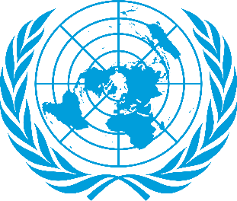
Position Paper

Practicing Freedom of Religion With a Special Emphasis
on Forcible Imposition of Religion on Young Children

Comittee: United Nations Children’s Fund
Country: Republic of Italy

The history of Italy covers the ancient period, the middle ages and the modern era. In antiquity Italy was the homeland of the Romans. Despite the presence of monotheistic religions within the empire, such as Judaism and early Christianity, Romans honored multiple deities. The Italian Renaissance spread to the rest of Europe, bringing a renewend interest in humanism, science, exploration and art with the start of modern era.Following the liberation of Italy, the 1946 Italian constitutional referendum abolished the monarchy and became a republic. The 1947 Constitution of the Italian Republic separated Church and state, Catholicism remained Italy’s official religion until 1984. The country is officially a secular state now. However, its religious and social landscape is deeply influenced by the Roman Catholic tradition. Indeed, the epicentre and government of the Catholic Church(the Vatican) and its leader (the Pope)are located in Rome.According to the constitution, all people are treated equally before the law regardless of their religious affiliation, and they are also free to publicly and privately practice their religions and promote them as long as they dont offend other’s morals.
Did you know 650 million girls and women alive today were married as children? While child marriage is a human rights violence, child marriage can lead to a lifetime of suffering. Girls who marry before they turn 18 are less likely to remain in school and more likely to experience domestic violence. Young teenage girls are more likely to die due to complications in pregnancy and childbirth than women in their 20s, and their children are more likely to be stillborn or die in the first month of life. Republic of Italy is deeply uncomfortable with what young girls are going through with the return of Taliban regime. The rates of child marriage have also increased by this provisions that have got enacted by Taliban regime. The United Nations mission in Afghanistan has documented numerous human rights violations that are reminiscent of their brutal rule in 1990s and also have a big effect and restriction on young girls. They have not only taken away their human rights, right to get education; They have also lost their freedom of thought, consience and religion which directly contravenes Article 14 of the Convention on the Rights of the child
Italian Government thinks the impact of religious leaders' on religious people and parents should not be ignored. The awareness they will spread is going to have a stronger effect on religious people since they are the ones who are the leaders of their faiths, which is the right one for them. More kind of practical ways to prevent this kind of child abuses and discriminations, to forbid it as some restrictions won’t be enough to change religious people’s mindset since as we said, their faith is the right one and they will somehow do it if they keep this is the right thing to do according to their beliefs. Religious leaders can change that and show them what does that actually cause and what is actually right. As Italy, we are ready to change this. We are ready to stop having more young girls are married, more children abused under the name of religions, more discriminations that cause physical and psychological effects that can not be ignored on people. We are calling all state members to deal with this together for children and people who only want to stay in peace with their beliefs.

