Position Paper – Delegation of Greece

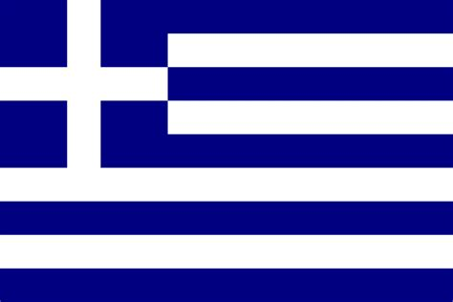
We, as the delegation of Greece, are honored to be in this conference to talk about the issue of freedom of religion in different countries. The Greek government supports that there must be freedom of religion everywhere. As Greece, we are open to requests and corporation with other countries, if necessary.
It is a known fact that the Greek population is mostly Orthodox Christians. The belief goes back almost three thousand years. We have been Orthodox Christians. We will try to defend this religion, to secure our history and respect our relatives. The European Law anticipates that European countries, such as Germany, France and Greece has to give the children right to freedom of religion. In any Greek land, we allow the expression of any type of religion, however the Greek government believes that the education of Christianity for children till the age of fifteen is mandatory and necessary. The common belief of our country is that this policy should not be changed and has great reasons behind it.
The change of this policy was requested by the Supreme Administrative Court. To further understand our perspective, we present the fact that we allow students to be exempt from the religion classes if they and their families prove that they are not Christians. With this conference, we believe that the freedom of religion problem will be solved. We propose that countries can have different laws, along with their different beliefs. Countries like us, who want to protect their history and religion should have rights to have mandatory religion classes until the age of fifteen or so. It is up to country’s government to decide whether it should be mandatory or not.
We will defend our opinions on this topic and would to like to share further opinions. We aim to find common ground with the members of the UNICEF committee. We wish every country and delegate luck.

