POSITION PAPER
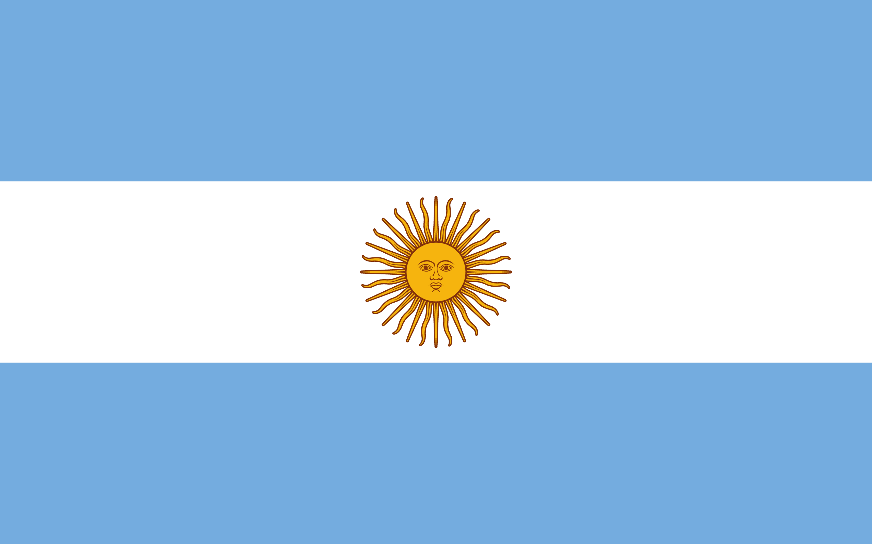
COUNTRY: Argentine Republic
COMMITTEE: ECOSOC/2
AGENDA ITEM: Cultural and Economic Reform and Optimization of the Post-Pandemic United Nations System

In this world, which is increasingly dependent on each other, it is a necessary behavior for countries to help each other in every way. The virtue of helping, which is in the nature of humanity, has been going on since the beginning of humanity.

Modernized humanitarian aid between countries started to be made after the 20th century. While giving aid, it should be done regardless of each other's political views, religions and races. At the same time, the countries that send aid should not block each other for their own benefit.

As the Argentine Republic, we attach great importance to helping countries in need and try to provide humanitarian aid as much as we can. For this reason, we have cooperated with many countries and organizations since the past. With our organization called White Helmets, which was established in 1994, which aims to send support to countries in need of assistance, the humanitarian aid we can provide to other countries has increased and gained momentum. Our White Helmets organization is in constant interaction with organizations such as the Red Cross. And for the aid they provide, an example of emergency aid can be given to the injured and those in need after the earthquake in Haiti.

According to our policy, we want other member states to think peacefully and act towards eliminating problems like us, and we are open to any innovations. We think that we need to support each other and put aside all differences while doing humanitarian aid.

