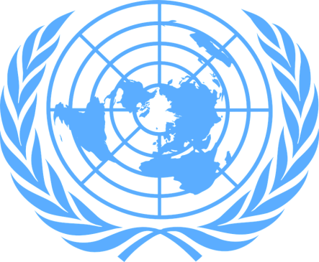
DELEGATE OF CANADA,POSITION PAPER
Country:Canada
Committee:UNICEF(The United Nations International Children’s Emergency Fund)
Topic:Practicig freedom of Religion With a Special Emphasis on Forcible Imposition of Religion on Young children
Canada is in Northern North America, bordering the North Atlantic Ocean on the east, North Pacific Ocean on the west, and the Arctic Ocean on the north, north of the conterminous US. . Their livelihood and small animal projects such as coffee farming, beekeeping, chicken rearing, plant husbandry, and fishing. Every Canadian citizen can access universal health care services that are publicly funded by the Canadian Government. Elementary and secondary school education is publicly funded in Canada by Federal, provincial, and local governments. Provinces determine the curriculum of what will be studied in schools. Both English and French language schools are funded. Population of Canada is 38,232,593. Canadian people are multiracial and have freedom of religion.
Discrimination because of religion is against the law in Canada and religious freedom in Canada is an essential right. Regardless of what you believe or practice, and whether you subscribe to a particular set of religious beliefs or don’t, protecting freedom of religion is an important part of ensuring that all people are treated with equal dignity and respect. Freedom of religion in Canada is protected by the Canadian Charter of Human Rights and Freedoms and Canadian Human Rights Act.

There are an estimated ten thousand distinct religions worldwide and about 84% of the world is affiliated with Christianity, Islam, Judaism, Hinduism, Buddhism, or one of the smaller religions. However, many of those who are part of that 84% could have been forced into that religion by parents, friends, or other influences in their lives as children. Religiously-based psychological abuse of children can involve using teachings to subjugate children through fear, or indoctrinating the child in the beliefs of their particular religion whilst suppressing other perspectives. A child will always believe what they want to believe, no matter how much those beliefs are forced. Kids are less likely to be interested in religion and practising, if they are forced into it. Freedom of religion is crucial to maintaining a private sphere for individuals and communities where the government does not and cannot intrude. The state should be neutral and impartial when it comes to matters of deeply-held personal beliefs.

